**August 2023**

# 

# **SoilMate**

**BUSINESS PLAN**

***Advancing Agriculture: Tech-Driven Soil Analysis***

*This document contains confidential and proprietary information of SoilMate and is intended for internal use only. Any reproduction, distribution, or use without the express written consent of SoilMate is strictly prohibited.*

**TABLE OF CONTENTS**

**SoilMate 1**

1. Problem Statement - The issue and its implication 3

2. Value Proposition - Identifying how to solve the problem 3

3. Product Description - Our solution 4

4. Our Market - Who would benefit from this solution 5

5. Financial Planning 7

6. Revenue Model 9

7. Distribution/Go-To Market 9

8. Competition and Competitive Strategy 12

9. Barriers Of Entry 13

10. Selling and Customer Relationship 16

11. Why Now? 17

12. The Team - Why Us? 19

13. Key Resources and Partners 20

14. Execution and Timeline 21

Appendices 22

Appendix A: Problem statement 22

Appendix B: Information regarding device use and details 23

Appendix C: SoilMate Device Propositions 25

Appendix D: Further Justification of Features 25

Appendix E: Market Segments and Detailed Analysis 27

Appendix F: SOM, SAM, TAM 30

Appendix G: Rationale for Revenue Model 31

Appendix H: Detailed Competition Overview 31

Appendix I: Grading of Difficulty scores 51

Appendix J: SoilMate Mitigation Strategy 51

Appendix K: Details on barriers to entry 57

Appendix L: Employee Timeline 71

Appendix M: Key partners 74

Appendix N: Gantt Chart for detailed timeline and a verbose overview of the timeline 77

Bibliography 83

#### **Problem Statement - The issue and its implication**

Soil testing is done by farmers to ensure that appropriate amounts of fertilizers and nutrients are applied to nourish their soil and facilitate healthy crop growth. Currently, farms test their soil through soil testing laboratories, which typically charge $20-40 per sample - resulting in an overall expense of $500-800 per test[1]. However, labs can take up to three weeks to provide soil test results to farmers; this delay can cause farmers to incur losses in revenue of up to $157,000 annually [1][18][34]. This brings about an opportunity for technology-based solutions to help solve this problem. See *Appendix A*for a more detailed explanation of our Problem Statement.

#### **Value Proposition - Identifying how to solve the problem**

SoilMate’s core value proposition is to provide the following soil health and nutrient information to users within **minutes**, and with **lab-comparable** precision: soil pH, soil electroconductivity, soil moisture content, soil type, soil nitrogen, phosphorus and potassium concentration, amongst other metrics we are currently exploring - thereby significantly shortening the wait-time experienced in laboratory soil-testing methods. Another valuable add-on would be the on-site setup provision, which will enable farmers to test as many soil samples they deem fit, eliminating a cost barrier imposed by the per-sample cost structure of soil-testing laboratories. These qualities are well sought after by farmers.

SoilMate also has a number of features and additions that compliment the core value it provides; these are listed in*Appendix B.* *and* *Appendix C*

While lab-driven soil sampling is proven to produce highly accurate results, its economic infeasibility and efficiency pitfalls stifled wide-spread adoption. The ideal soil sampling ratio of 1 sample per 2 acres via labs is thus infeasible. With SoilMate, this kind of testing will be economically viable and easy to implement for a wide variety of users [2], via its two-tiered subscription packages. The basic package will allow farmers to test up to 2,500 samples[2] in a single year at $100, whilst also allowing the possibility for additional samples, 50 more samples for $2 only.

With these capabilities, SoilMate will be able to provide real-time updates on soil health and parameter trends, allowing users to continuously monitor their soil health and mitigate nutrient losses. Additionally, users will be able to recoup their investment in SoilMate within **2 years[3]**, after which their soil-testing expense will be reduced to a reasonable subscription fee[4]. This is all possible due to our wide variety of features and the relatively low cost to achieve high accuracy in these features.

#### **Product Description - Our solution**

SoilMate will be an on-site, chemical-free, sensor-based soil testing device, integrating spectroscopy, IoT, Machine Learning, Sensors and Signal processing techniques into a coherent, deployable and easy-to-use end product aimed at estimating the following features:

* Testing multiple soil samples for nitrogen (N), phosphorous (P), potassium (K), pH, electrical conductivity and moisture content among other parameters.
* Soil Ion(calcium (Ca++), magnesium (Mg++), potassium (K+), ammonium (NH4+), nitrate (NO3-), hydrogen (H+) and sodium (Na+)) and micronutrients testing (carbon content, organic matter)
* Providing nutrient concentrations, fertilization quantities and crop recommendations based on farmer needs based on season, desired crop, region and soil type; direct to the consumer through via a mobile app.

The question arises, why are all these features important? Though more coherent & detailed justification can be found in *Appendix D**,* including details pertaining to how these metrics aid specific crops, here we will provide brief outlines regarding the reasoning for the inclusion of the NPK, Moisture, CEC, pH, and Electrical Conductivity.

**NPK** serves as the backbone for end user metrics, as it provides customers the opportunity to make informed decisions about the optimization of their fertilizer usage, saving them both time and money **($157,000/year)**[1][18].These important nutrient parameters would also help predict **key metrics** regardingplant health, yield and nutrition requirements for their crops, for example, corn can suffer up to a 40% yield loss without proper fertilization, and wheat up to 57%[4]. This is the major boon for our product, as accurate, reliable and quick results for NPK via spectrometry and ML model analysis would separate us from the competition.

Moisture, CEC, pH and Electrical Conductivity, amongst other parameters are all ones that we can target with sensors, whilst still being part of a single coherent system. **Moisture retention** helps decide the longevity and yield of the crop, as moisture in the soil is important for the transport and breakdown of ions into usable nutrients for the plant[5]. Different soil types vary in their moisture retentivity, and changes to this retentivity due to factors like temperature are difficult to plan for during the crop cycle without adequate information about the soil’s nature[6]. Measuring **CEC** (Cation Exchange Capacity), which is an aggregate sum of all ionic content in the soil, can help the farmer choose the type of crop to plant, budget their investment into micronutrients and prevent crop infection, as an appropriate CEC range helps boost the crop’s resistance against diseases[8].

**pH** is also incredibly important, as different plants also grow optimally in different pH environments, blueberries for example, grow well in acidic soil, with a pH between 4.5 and 5.5, whilst most crops prefer a pH between 6 and 7.5[7]. Soil pH level would help our customers make informed decisions about where to plant crops, and where to increase or decrease pH in order to facilitate optimal growth. A soil sample’s **Electrical Conductivity** is a key indicator of the average lifespan and health of the plant in said soil, and aids our end user in important decisions regarding their next crop to grow and where to adjust nutrient needs[8].

#### **Our Market - Who would benefit from this solution**

*Initial customer segmentation is done in three regions - Canada, India and the GCC4 due to the significant interest generated here during the incubation stage.*

*For detailed description and analysis, refer to* *Appendix E*

**Canada Market Segmentation**

**Urban Farmers:** Tech-savvy, mid-sized family farms, particularly in grain, oilseed, fruit and vegetable cultivation. This segment represents **~40%** of the market.

**Precision Farmers:** Highly experienced farmers or organizations that value detailed micro and macronutrient soil reports. This group makes up **~10%** of the market.

**Convenience Farmers:** Traditional farmers who value comfort and convenience in their soil testing processes, representing **15%** of the market.

**Best-Value Farmers:** Large-scale farmers/corporations prioritizing a balance of convenience, accuracy, time, and cost. This segment covers **30%** of the market.

**India Market Segmentation**

**Large-Scale Farmers:** Educated farmers operating over 10 hectares, representing around 0.57% of the farming population but controlling nearly 19.31% of farmland.

**Farmer Unions:** Organized groups of farmers (Farmer Producer Organizations) that procure agricultural equipment and technologies in bulk for their members.

**Local Governments:** Local government units in farming states seeking to support their farming communities.

**Oman and Gulf Cooperation Council[5] Market Segmentation**

**Greenhouses:** Fast-growing industry seeking efficient resource management through precise soil health analysis.

**Agritech Distributors:** Companies aiming to enhance agricultural productivity and sustainability in alignment with Oman's Vision 2040.

**Research Institutions:** Academics and researchers requiring sophisticated, real-time soil analysis tools.

**Total Obtainable Market**

The global agriculture market and soil testing equipment market are growing at **CAGRs of 9.4% and 10.2%**, respectively. Investments in food and agribusiness have tripled since 2004, exceeding $100 billion. In Canada, there are 77,312 grain, oilseed, fruit, and vegetable farms[9][10]. The US has 525,000 such farms, while the potential Indian market stands at 440,000 units for large land-owning farmers [11]. The Middle East, particularly the GCC4, offers an opportunity in greenhouses, with a total market of 119,000 units [12][13][14]. Therefore, our TOM, based solely on the number of farms, is valued at **$4.5 Billion**.

A detailed breakdown of SOM, SAM and TAM is given in *Appendix F*

These regions have been selected based on initial interest generated during customer acquisition, market maturity and existing business relations.

* **Serviceable Markets**

The markets within our immediate focus, i.e. the next 5 years, are the Canadian provinces of Ontario and Alberta (where we observed **success rates of 20% and 7%** from customer outreach respectively), along with the United Arab Emirates and Oman in the Middle East and Tamil Nadu, Bihar and Kashmir in India. Other Canadian provinces known for a strong agricultural economy, such as Manitoba and Saskatchewan, are not in our immediate focus, as they have very large average farm sizes when compared to Ontario - leading to them having extensive operations, which causes a higher resistance to market penetration[6].

Considering this, our market sizing is as follows:

***Serviceable Accessible Market (SAM)***[7] = **11,455 units**, which amounts to **Cn$39.5M**.

Our SAM is broken down as follows:

* *Sales in Ontario = 4,400[8]*
* *Sales in Alberta = 1,000[9]*
* *Sales in UAE and Oman = 4,100 (3,500 in UAE, 600 in Oman): there is a total market of 35,000 units in UAE and 6000 units in Oman. We aim to acquire 10% of these markets over the next 5 years. We believe this is an attainable target considering our manufacturing capacity and ease of market access through connections, market reach and continual customer acquisition.*
* *Sales in India = 855 (Farm unions)*
* *Soft promises in India = 1,100 (Bihar, Kashmir and Tamil Nadu)*

***Serviceable Obtainable Market (SOM)***[10] = **3,064 units**, which amounts to **Cn$10.5M** (inclusive of both sales and revenue from subscription fees).

Our SOM is broken down as follows:

* *Soft promises in India = 1,100*
* *Sales in UAE and Oman = 1,640 (1400 in UAE, 240 in Oman)*
* *Sales in Ontario = 176*
* *Sales in Alberta = 40*

Further details on our market estimations are included in *Appendix F.*

#### **Financial Planning**

This subsection will outline the cost structure of our business plan, which includes the Research & Development (R&D) phase, the manufacturing phase, operating costs, and other administrative expenses. The assumptions and justifications used to estimate each cost are included in *Appendix L*

The costs may vary based on factors like changes in market rates, unexpected cost increases, exchange rate fluctuations, and other unforeseen circumstances. We acknowledge the importance of revisiting these assumptions periodically to ensure they are still valid as the project progresses.

We aim to seek funding from venture capitalists and angel investors that we've had previous business relations with, and those who have shown interest in the product, as we continue fulfilling our goals.

**Investment Procurement and Deployment Plan**

| **Investment Round** | **Timestamp** | **Amount (CAD)** | **Deployment** |
| --- | --- | --- | --- |
| Pre-seed | Aug/Sep 2023 | $133,500 | Prototype development and trials |
| Seed | Feb 2024 | $150,000 | Manufacturing planning and CAPEX |
| Series A | Jul/Oct 2024 | $500,000 | Manufacturing kick-off and product launch |
| **Total investments (CAD)** | | **$783,500** | |

The above table briefly mentions the investments we will need to begin operations. The accompanying cash flow model spreadsheet contains details regarding all projected cash inflows and outflows.

**R&D Phase**

| **Expense Category** | **Details** | **Amount (CAD)** |
| --- | --- | --- |
| *Prototyping Costs* | Cost for creating and testing 11 prototypes, spare parts included. | $51,194 |
| *Team Salaries* | Salaries for machine learning engineer, mechanical design engineer, agrochemist and electro-optics engineer. | $18,000 |
| *Infrastructure Costs* | Cost for server and cloud services including AWS, Google Collab, domain name, and web application hosting fee. | $7,584/year |
| *Logistics and Travel* | Cost for shipping prototypes to various locations. | $13,725 |
| *Testing Expenses* | Cost for spectroscope and chemical lab setup for testing. | $25,000 |
| *Administrative Costs* | Cost for business/company setup, IP, and licensing costs. | $2,000 |
| **Total Budget** | | **$117,503** |

**Manufacturing Phase**

| **Expense Category** | **Details** | **Cost Per Unit of Measurement (UoM) (CAD)** |
| --- | --- | --- |
| *Unit Production Cost* | Cost of materials and manufacturing per unit | $1,887 per unit |
| *Team Salaries* | Salaries for a team of engineers | $3,917 per month from May’24 to Apr’25; $5,500 per month May’25 onwards |
| *Manufacturing and Packaging* | Costs of ABS plastic molding, assembly, packaging, product testing, etc. | $110 per unit |
| *Warehousing and Logistics* | Cost of warehousing in India and Canada | $1,489 per month |
| *Freight and Delivery* | Cost of end-to-end delivery | Variable, please refer spreadsheet |
| *Infrastructure Costs* | Annual cost for service and cloud services. | $7,584 per year |
| *Customer Acquisition Costs* | Cost for marketing and promotional activities aimed at attracting new customers. | $5,083 per month |
| *Maintenance Costs* | Costs for maintenance, repairs, warranty, replacements, and returns. | ~5% of monthly revenue, per month basis |

Understanding the priority of our fixed and variable costs provides us with a strategic view of where our main financial commitments lie. It's clear that the manufacturing phase, which includes production, assembly, packaging, and quality control, demands the bulk of our financial resources.

Simultaneously, we cannot ignore the significant fixed costs associated with staff salaries and other operational costs. These are investments in our team's capabilities and operational efficiency, ensuring we have the right talent and systems to develop and deliver a high-quality product.

On the variable costs side, we aim to optimize our manufacturing processes and logistics to achieve cost efficiencies. These areas have the highest costs per unit, and any savings here would have a significant impact on our overall profitability.

Finally, we also must consider factors like inflation, exchange rates, and market demand fluctuations, which are not factored into this analysis but could impact the cost structure. By being aware of our cost priorities and maintaining flexibility in our financial planning, we can better manage these risks and ensure the financial sustainability of our business.

#### **Revenue Model**

*Rationale for revenue model in* *Appendix G*

Our research has indicated that most farmers in the Canadian market would prefer to buy rather than lease farm equipment. This preference is largely due to familiarity with the traditional model of purchasing and the security that comes with ownership.

Keeping customer sentiment in mind, SoilMate, due to the nature of the solution, would have a revenue model that would be generating two revenue streams.

1. Direct sale of Soilmate devices to entities. The access to the device is essential for anyone to test their soil, however it isn’t sufficient. Which brings us to the second point below:
2. Two-tiered subscription for access and usage of SoilMate’s cloud based app. Dual tier subscription is required to provide more than ample testing capacity for farmers that would be using the box only for themselves, and to prevent our buyers from leasing the product further at our loss to farmers around them. Therefore, $100 per year up to 2500 tests, and then $2 for 50 tests additionally.

The selling price of the device, at present, is estimated to be $3433 for direct sales to farmers and agronomists, and $2747 for bulk sales at a discount of 20% to distributors and agro-organisations. This price has been determined using the following factors:

1. Quality of materials and parts used in constructing the product.
2. **A mark-up of 100%**: this number was determined from discussions with parties in the agricultural and agro-tech industry. However, given our 90/10 ratio of international to Canadian sales, a blended price has been calculated for each. A markup of 100% was applied to the total unit cost price for Canadian sales, and 80% for international sales. A weighted average of the two was then taken (90% for international, 10% for Canada) and this was determined to be the final selling price in Canada. Applying a 20% discount to this amount, we determined the selling price for international sales. Further details are included in the accompanying spreadsheet of cash flows.
3. Competitive pricing: we recognize the buying power of the customers in our target segment and the products currently available in the market, and plan to penetrate the market by pursuing a low-cost and competitive based pricing strategy.

#### **Distribution/Go-To Market**

* 1. *Timeline for introducing SoilMate to the market*

Our timeline for introducing SoilMate to the market is as follows:

* August/September 2023: Secure pre-seed funding / grant
* October 2023: Deploy funding amount towards product R&D and prototype development. Our team has identified multiple avenues for patenting our intellectual property, and will take action on the same during this period.
* February 2024: Secure a seed fund of $150,000. We have, at present, identified a need to develop and distribute **11 prototypes** strategically around the world with our enthusiastic early adopters across multiple locations - Ontario, Alberta, multiple states of India, Oman, UAE and the rest of GCC - to test for validity of hardware and product performance. These paying customers are early market partnerships ( India and the GCC) and tech-savvy risk tolerant farmers in Ontario/Alberta that we began to identify in March 2023 and nurture over the course of the year.
* June 2024: conclude trial phase and seek series A funding of ~ $500,000.
* July 2024: After receiving the first installment of series A worth $250,000, we aim for a product launch - begin full-scale production of units as per plan and introduce SoilMate to the market.
* October 2024 : receive the second installment of series A funding worth $250,000.
* August 2024 - August 2026: focus on closing soft promises and premature sales that were made in the ideation, product development and business development stage (early 2023) stage.
  + After this, we can expand with market validation and product credibility into our identified target market segments. As entailed in the ‘Customer Validation’ section, we will then focus on increasing our penetration within these markets.
  1. *Requirements for a successful product launch*

The components for the successful launch of SoilMate in the market have been identified to be:

* Security of intellectual property that delivers value on par or greater than the competitors.
* Certifications of standardization and quality, and any other legalities of each region we’re targeting.
* Adequate robust generalized ML system that can collect data with low overhead.
* Successful conclusion of trial and testing phase, thereby affirming our product’s usability, benefit and interest.
  1. *Plan for initial product distribution in targeted regions*

Providing value to the end user can be accomplished either through direct ownership of the device, or as a shared service, managed by an entity that purchases the product from us. However, the SoilMate company will not start our own service based model because the cost of operation isn’t feasible. The product's pricing strategy encourages ownership and offers flexibility tailored to our overseas markets, particularly in India and the Middle East. By strategically aligning with distributors and agro-organizations, we empower them to adopt a service-based model for our product.

Using our affiliations, we plan our initial sales by entering our product in Canada, India, Oman and the UAE:

* India: In India, we plan to fulfill our initial 1100 soft promises within the first 2 years of our inception. We then plan to target the identified market of **$1.21B (**440,000 farmers in India with land over 25 hectares - farmers with the means to purchase our product) via direct shipping from manufacturers as well as via distributorship models from farm unions, after establishing credibility and relations. As a potential future plan, we can eventually target a partnership from entities or distributors that would be willing to set up a soil-testing service based model, thereby increasing our TAM in India by becoming accessible to farmers much below the 25 hectare limit.
* Oman, UAE and the GCC: Our target market in this region is greenhouses, and we plan to tap into this market via distributorship models in various countries. To begin with, we will target UAE and Oman - wherein have identified a total addressable market of **$140.8M** (41,000 greenhouse farms) - for the next 5 years. We plan to sign a distributorship agreement with organizations such as *Unicorn International LLC*, who will be required to maintain inventory and grow sales in their respective regions, and to whom, we will sell our units at a bulk discount rate of **20%**. The agreement will contain details regarding the suggested retail price of the product, sales projections as well as the shares of revenue from mobile-app subscription fees, to list a few. We will provide marketing support and resources to our distributors when necessary, however, we anticipate higher penetration via distributors in their respective regions due to their strong market presence and existing customer relationships in said regions.
* Canada: We have encountered strongly favorable market feedback from the provinces of Ontario and Alberta. We have identified soft sales for 20 units in these provinces, which we plan to fulfill initially, after which, we will further expand our market share in these provinces and initiate entry in the provinces of Manitoba and Saskatchewan. We assume that it will be easier to expand through the networks of our initial 20 customers - friends, acquaintances, organizations, etc. As mentioned in the customer acquisition strategy, apart from advertisements over our target demographics’ most used mediums and cold-calling, we will be building awareness through agro-conventions and trade shows. Furthermore, we plan to leverage our mentors’ relationships within the agricultural industry in North America to grow our penetration.
  1. *Cost-feasibility study*

As shown in the accompanying detailed spreadsheet on company financials, this combination of B2C sales, distributorship sales and mobile-app subscription fees is feasible. With these measures, we expect to operate at full production by June 2024, we expect our **first break even point in June 2025**, as further elaborated in the cash flow.

#### **Competition and Competitive Strategy**

We define a competitor to be any medium that tests farm soil nutrition make-up and provides results which can be interpreted to determine the corresponding fertilizer requirements. We have identified the following major competitors operating through different business models (for additional details on competitor analysis, such as histories, key personalities, management style and funding of competitors, refer to *Appendix H* ). In the competitive landscape, we stand distinctly apart due to our value proposition and innovative approach to soil analysis.

1. **Shipment/Service Based Solutions**

**Honeyland AG Services** is an Ontario based company which helps to provide results for fertilizer and watering dose among others to help better manage farmer’s inputs for their agriculture. They seek growth by forming strong partnerships within the industry and focusing on innovation. They charge **250$** per field for Nitrogen sampling and also offer soil tests ranging from $19- 47.50 per sample.

**A&L Canada Laboratories** is another Ontario based company that provides comprehensive analytical services for soil, plant tissue, feed, fertilizer and water metrics along with production recommendations. They incorporate a transactional and usage based revenue model, and charge for parts/replacement parts for their analysis tools.

**Eurofins Scientific** is a laboratory group based in Luxembourg, serving the pharmaceutical, food, environmental, agriscience, and consumer product sectors, employs over 61,000 staff across 900 laboratories in 61 countries. The company invests in R&D for cutting-edge biotechnology and analytical chemistry solutions. Predicting substantial growth, they anticipate revenues nearing €10bn for FY2027, using a usage-based revenue model.

**The Agriculture and Food Lab (AFL), at the University of Guelph** led by Dr. Rafikali Momin, is a preferred lab partner for the Canadian government and universities in agriculture, food safety, and animal health testing. Their 2022 revenue from services, including soil testing, rose by 5% to $22.3 million. They operate a usage-based revenue model with a Residential Lawn & Garden Fertility Package priced at $65.65 per sample, offering a range of soil tests.

1. **Wet Chemical Based On Site Solutions**

**Martin Lishman Ltd.** is a UK based company with global presence that is focused on manufacturing and distributing specialist agricultural equipment for a varied user base. An important product of theirs is the Barn Owl Wireless series-a range of wireless crop monitoring and automatic fan control systems. They report a revenue of 6.4 million pounds.

**LaMotte Company** is an American company based in Maryland that offers water testing and wet chemistry-based soil and plant testing kits worldwide. Their kits measure nutrient and pH levels for soil fertility assessment and yield optimization. However, their accuracy, while compliant with industry standards, falls short of traditional wet chemistry labs.

**Nagarjuna Agro Chemical** is an Indian based in Hyderabad that specializes in soil testing. Their notable product, the Mridaparikshak, is a portable mini lab that analyzes key soil parameters. Developed in partnership with ANGR Agricultural University, this device caters to diverse soil conditions and provides immediate soil health data and communicates fertilizer recommendations directly to farmers via SMS.

1. **Hardware/Chemical Free On Site Solutions**

**ChrysaLabs** is a Quebecois company that develops and sells a ground probe for active farm monitoring, reporting macronutrients, micronutrients, and other parameters. Their machine learning platform, optimized by data scientists, continually learns from user data. Catering to high-end farmers needing active soil testing, they charge approximately $10,000 annually. Their services span 6 Canadian Provinces and 25 US States.

**Neoperk Technologies**, a Maharashtra-based AgTech company, provides similar but less accurate technology to ChyrsaLabs at a lower cost. With a team of 6-10, they plan to expand across India in five years and develop a soil intelligence platform for innovative soil market products. They target small rural farms and currently serve 2320 customers.

**AgroCares**, located in the Netherlands, uses sensor technology to analyze soil, leaf, and feed nutrients in real-time. Their key products, the SoilCares Scanner and Lab-in-a-Box offer on-site testing, with the latter providing crop recommendations and fertilizer application timings. The company, supported by Dutch investors, prices their scanner package at $3950 and an annual unlimited soil scanning service at $2230.

**Stenon** is a German company mainly operating in the EU countries Germany, Austria and Switzerland, whose mission is to develop soil analysis technology designed to provide independent real-time analysis to individual farms. They have received over 26.8M USD in funding, and are listed as one of the hottest startups in Berlin according to WIRED magazine.

**Teralytic**, a New York-based firm, is gearing up to distribute their $3300/year soil probe that delivers in-depth soil quality data, suitable for remote areas with its no-wifi, LoRa-based network. The company reaches out to diverse farms through direct sales, consultations, and online marketing. They successfully raised $9.72M in 2020, building on a seed fund total of $9.04M from 01 Ventures.

#### **Barriers Of Entry**

**SWOT Analysis**

| **Strengths**   1. Market: ready customer base in India and Canada, significant interest for product introduction in the GCC via known market partners. Strong potential in certain parts of India, Africa and Australia via known channels. Furthermore, the team has relationships with government authorities in India and GCC. 2. Price: product performance expected to be at least equivalent to (if not better) market-leading competitors’ offerings - at a fraction of the price. 3. Product: industry leading AI and ML software that would have far lesser dependance on data. 4. Founding and advisory team: founders have a diverse skill set and the advisory team is well connected with leaders in the agri-tech and venture capital industries. | **Weaknesses**   1. Number of parameters that can be tested with SoilMate are less - major competitors are able to test up to 93 parameters. 2. The company does not have a product ready to be launched into the market. Product launch will be in over a year from now - which allows plenty of time for newer entrants to capture our market or for market dynamics to change unexpectedly. 3. Access to significant funding - or grants is required for product development and launch, which increases risk and can lead to further unexpected delays. 4. Absence of brand image and product validation - which can lead to interested potential customers losing interest in the product. |
| --- | --- |
| **Opportunities**   1. None of the competitors identified so far have been able to capture any significant market share in India, N. America or the GCC, providing opportunities for significant market penetration. 2. Strong potential in the greenhouse farming markets in the GCC, allowing for an opportunity for expansion. 3. Shift towards technological solutions and away from traditional solutions - especially in regions such as the GCC, who heavily promote such technologies. This poses a promising timed opportunity for market entry. 4. Increased and improved public consumer access to social and digital media poses an opportunity for brand building and image creation. 5. Surge in fields such as farm and agriculture consulting implies opportunities for possible collaboration. 6. Increased government spending to develop agriculture-oriented programs in various economies worldwide suggests opportunities for receiving grants and/or government interest. | **Threats**   1. Existence of a high number of competitors - several competitors have product offerings with comparable (and better) capabilities than those of SoilMate. 2. Hardware manufacturing is an important step in business operations - thereby any delays or faults in the supply chains pertaining to component supplies (sensors, electronics etc.) would have a negative impact on production and sales. 3. R&D intensive business - any snags that hinder continual R&D could have a direct impact on the product, which could spoil brand image in the market and/or lead to customer attrition. 4. Product counterfeits - being a hardware product, there is always a threat of duplication, and counterfeit products entering the market. |

*For details on the following sections, refer to* *Appendix K*

1. **Government Regulations/ Laws/ Codes/ Standards**
2. Product Safety and Compliance
   1. Measurement Canada
   2. Health Canada
   3. Environment and Climate Change Canada (ECCC)
   4. Standards Council of Canada (SCC)
   5. Provincial Regulations
   6. Intellectual Property (IP) Laws
3. Import/Export Regulations
4. Privacy Laws
5. Labelling, Advertising, and Language Requirements
6. **Educational Barrier**
7. Lack of information on the importance of soil testing among farmers
8. Pushback to adopt newer soil testing methods (e.g., Spectroscopy)
9. General lack of information among customers
10. **Existing Relationships**
11. Farmers and Labs
12. Labs and Fertilizer Companies
13. Farmers and Fertilizer Companies
14. Tangible and Intangible Cost Considerations
15. **Technological Constraints**
16. Limited Technological Infrastructure in Rural Areas
17. Varied Technological Literacy Among Farmers
18. **Economic Considerations and Price Sensitivity**
19. Price Sensitivity Among Farmers
20. Variable and Unpredictable Farming Income
21. **Multifaceted Complexities of Grain and Oilseed Farming**
22. High Dependency on Traditional Farming Practices
23. Geographic Dispersion and Variability of Farms
24. Crop-Specific Challenges
25. Strategic Market Positioning
26. **Competitor Reaction**
27. Enhanced Service Offering
28. Aggressive Marketing Campaigns
29. Strategic Alliances and Partnerships
30. Price Reduction
31. Development of Similar Technologies
32. Long-term contracts with customers

By anticipating these potential reactions, we can develop strategies to address them effectively, ensuring our successful entry into the soil testing market.

**Soilmate's Mitigation Strategy**

Soilmate's aims to mitigate these issues by emphasizing its distinction from the competition that lies in its superior technology, customer relationships, complementary partnerships, value-based pricing, and commitment to continual innovation, even in the face of aggressive competitive strategies (for further insight as to how we excel beyond our competitors refer to *Appendix J* *- Soilmate’s Mitigation Strategy*).

1. Superior Technology and Real-time Data Analysis
2. Ease of Use and Customer Relationships
3. Comprehensive Soil Health Analysis and Complementary Partnerships
4. Environmental Sustainability
5. Value-based Pricing and Cost-effectiveness
6. Continual Innovation

From a value perspective, Soilmate offers an enticing blend of real-time, comprehensive soil health information, user-friendly operation, and environmental sustainability. We don't aim to compete purely on cost but on the tangible value and improvements our solution brings to farmers' operations. Soilmate's advantage lies in its deep understanding of customer needs, its unique value proposition, its commitment to innovation, and its ability to build strong, lasting relationships with customers. These strengths place us in a formidable position, even in the face of aggressive competitive strategies.

#### **Selling and Customer Relationship**

1. Customer Acquisition Strategy

Our acquisition strategy involves a blend of traditional and digital marketing to reach the farming community, which is gradually embracing digitalization while still valuing traditional channels[11]. We'll utilize digital platforms like social media, farming forums, and digital trade publications to highlight our product's precision, convenience, and yield optimization potential. Concurrently, we will also invest in traditional channels like trade shows, agricultural fairs, and print publications for face-to-face interaction[12].

Our strategy includes a mix of paid advertising, content marketing, and relationship building. This approach is complemented by partnering with established farm distribution channels, expediting our market penetration and easing logistics. We will use a multi-dimensional sales approach, employing a team of skilled salespeople who can handle technical presentations and personal interactions. Our online platform will also provide a direct selling method, breaking geographical barriers, and improving accessibility. This comprehensive approach ensures our technology is available to all farmers and helps build trust and loyalty, crucial elements for customer engagement[13].

1. Customer Relationship Management

Our strategy for managing customer relations revolves around exceptional service and continuous engagement. We'll employ a dedicated customer service team to ensure proficiency, uniformity, accessibility, relationship enhancement, and feedback collection. Other customer service methods like self-service options, automated services, and community forums will cater to diverse customer needs, enhancing their overall experience. Key components of our customer relations pipeline include contact management, interaction tracking, task management, and reporting and analytics.

We'll implement Key Performance Indicators (KPIs) (detailed in *Appendix J*) to measure the effectiveness of our sales and customer engagement strategies. Regular updates on soil health, technology advancements, and best farming practices will keep customers informed and engaged fostering a sense of belonging and co-creation.

#### **Why Now?**

Modern tech hasn’t penetrated the world of agriculture to the extent expected. With climate change on a rampant rise, it is the penultimate hour to address related soil health issues such as high nutrient volatility and soil-quality degradation, as they directly affect crop yields[15].

**Surging Demand for Increased Crop Yields:** As the world's population recently crossed the 8 billion mark and continues to grow at a rate of 1% annually, the global food demand is expected to surge by 35% to 56% between 2010 and 2050. Concurrently, efforts to mitigate the risk of hunger have the potential to fluctuate between a decrease of 91% to an increase of 8% over the same period [16]. These dynamics underscore the need to maximize the efficiency of key agricultural processes like soil testing, in order to boost yields and fulfill the escalating food demands.

The United Nations Food and Agriculture Organization projects that global food production must surge by 70% by 2050 to nourish the anticipated population of 9.7 billion. This demographic reality amplifies the pressure on farmers to optimize their yields, setting the stage for Soilmate's value proposition. By providing real-time, precise data about soil health, Soilmate empowers farmers to make informed decisions about fertilizer usage, irrigation, and crop rotation strategies. As a result, they can significantly enhance their productivity and crop yield, meeting the burgeoning food demand and contributing towards global food security.

**Technology Adoption Among Farmers:** The Canadian agricultural industry has experienced a digital revolution over the past decade. The agrotech boom has witnessed a shift towards data-driven decision making, driven by the promise of increased efficiency and productivity. According to Farm Credit Canada's 2021 survey, 61% of farmers in Canada have embraced agrotech solutions, reflecting this change in mindset. Tools like precision farming systems, yield monitoring, and automated irrigation have already found acceptance. Now, as old farmers become more comfortable with technology and a new tech-savvy generation of farmers emerges, it is an opportune moment to introduce Soilmate, a device that builds on this digital momentum.

**Sustainability Focus:** There is an increasing focus globally on sustainability and responsible farming practices. The challenges of climate change and the need to preserve resources for future generations are driving the search for sustainable farming methods. The Canadian Federation of Agriculture's 2022 survey revealed that 85% of Canadian farmers believe technology is necessary to achieve sustainability goals. Tools like Soilmate that promote efficient fertilizer use not only reduce costs but also mitigate the environmental impact of excessive fertilizer use, which leads to soil degradation and water pollution.

**Ripe Market for Competition:** The soil health device market is ripe for competition. While there are a few players in the market, no single product has managed to capture a significant market share, indicating that there is room for innovation and improvement. As a second mover, Soilmate has the opportunity to learn from the mistakes and shortcomings of the first movers and better address the needs and pain points of farmers.

**Need of the hour:** Climate change is making soil health more volatile and necessitates the need for quicker and more iterable models of soil testing than current wet chemistry labs provide. While 90% of farmers are aware of the benefits of soil testing, many choose to do it less frequently due to the current incumbent’s tedious operating procedures[17]. Farmers can lose up to $107,000/year in potential benefits due to soil degradation[18] and weak plant health[19] which are preventable through frequent soil testing and monitoring. With SoilMate, farmers can regularly test their soil, obtain reliable information in order to manage their soil nutrients and ameliorate their soil health.

**Strict government mandate on fertilizers:** The government of Canada aims to reduce GHG emissions due to the usage of nitrogen fertilizers by 30%[20], but this change may cost the farmer an aggregate of $48 billion[21] in the form of lost potential produce per arable land area. SoilMate’s algorithm and phone app will allow the farmer to optimize their fertilizer usage efficiency based on crop cycle, crop type, soil type and other metrics and help them mitigate this loss.

These factors present an opportune moment for Soilmate to carve a significant place in the market. We aim to harness these trends and present a solution that is not just a device but a comprehensive soil health partner for farmers.

#### **The Team - Why Us?**

| **Member** | **Training** | **Job Description** | **Equity(%)** | **Vesting Schedule(years)** | **Vesting Cliff(years)** | **Expertise and Contribution** |
| --- | --- | --- | --- | --- | --- | --- |
| Abhay Gupta | Engineering Science | Chief Financial Officer | 20 | 4 | 2 | - Logistics  - Business processes/ expansion |
| Ritvik Singh | Engineering Science with major in AI | Chief Operating Officer | 20 | 4 | 2 | - AI/ML models  - Real time data processing  - AgroTech space experience with Indian Government and NGOs |
| Shalin Bakshi | Mechanical Engineering with Minor in Business | Chief Executive  Officer | 20 | 4 | 2 | -Manufacturing design  - Heat management systems  - Financial Management |
| Shaurya Benipuri | Computer Engineering | VP Outreach | 20 | 4 | 2 | - Production and deployment of applications complete with frontend and backend infrastructures and IoT. |
| Vidhan Purohit | Electrical Engineer with minor in Control Systems | Chief  Technology  Officer | 20 | 4 | 2 | -Real time signal processing circuits  -Soil nutrient chemistry analysis |

Members of the team bring strong connections with agricultural organizations, government bodies and farmers in India, Canada and the GCC that have provided us with a soft sales promise which we will fulfill in our first 2 years after production

**Hiring Timeline**

| **Quarter** | **Employees and Salaries** |
| --- | --- |
| **1** | * 3 ML engineers at $30000/per year * 1 Agro-chemist specializing in environmental chemistry at $5000/year * 1 Electrical Optics engineer at $6000/year |
| **2** | * 1 Full Stack Developer at $8000/year * 2 Software Installation Engineers at $16000/year * 1 Mechanical Design Engineer at $6000/year |
| **3** | * 1 Customer Service representative at $4000/year |
| **4** | * 1 Canadian Sales rep experienced in selling hardware electronics at $50000/year * 1 Warehouse Manager in India at $6000/year |
| **5-6** | No Additional Hires |
| **7** | * 1 Agro-chemist specializing in environmental chemistry at $5000/year * 1 Electrical Optics engineer at $6000/year * 1 Full Stack Developer at $8000/year |
| **8** | No Additional Hires |

Detailed contributions of the co-founders to the value proposition, hiring timeline and salary, number of employees, employee roles, training and travel costs, skills and responsibilities are all justified in *Appendix L.*

#### **Key Resources and Partners**

*For details including comprehensive list of partners and advisors, refer to* *Appendix M*

1. Financial Resources

SoilMate's business model necessitates significant resources for its extensive operational landscape, which includes R&D, manufacturing, marketing, and sales. The financial planning section projects an initial capital of $120,000 for R&D, escalating to an overall budget of $7,050,000 in the first two years, accommodating the comprehensive costs for manufacturing, salaries, logistics and infrastructure for our anticipated production.

Our financial strategy is to secure funding from a diverse set of sources, scoping to explore venture capital opportunities, bootstrapping through sales revenue, leveraging low-interest business loans, and seeking angel investments. Regardless of the method, we're dedicated to funding our innovation and achieving our business objectives.

1. Intellectual Resources and Partners

SoilMate's core strength lies in its proprietary IP, especially the innovative technology we've developed for soil parameter sensing technology and our proprietary methods for soil health and nutrient analysis. We also have a robust network of partnerships, crucial for our research and development efforts, including the FIELDS Institute of Mathematics, Kimia Analytics, and the Department of Agriculture in Kashmir, supplemented by relationships with academicians in relevant fields, including AI and ML.

Our strategy to protect our uniqueness and value proposition revolves around rigorous R&D to continuously improve our product and services and strengthen our IP portfolio through copyrights, patents, and exclusive partnerships. As we scale, we're mindful of potential gaps in technology, talent, or knowledge, and continually strive to bridge these through strategic recruitment and partnerships with research institutions.

1. Physical Resources and Partners

Our physical resources include a variety of hardware components essential to manufacturing our soil health analysis product. These elements comprise ABS plastic, visible and IR LEDs, Raspberry Pi, Arduino Mega, an array of specialized sensors (including ion-selective, pH, EC, and moisture sensors), a cooling system, and an LCD display screen, among others. Our operations heavily rely on software infrastructure like AWS Cloud Services for cloud computing services, enabling scalability and data storage, and Google Collab for Cloud ML computation, collaborative research and product development efforts. Our other suppliers and server management partners include ThorLabs - Optical Equipment, LMS - NIR LEDs, Bluehost - Web Hosting and GoDaddy - Domain Services.

Our physical assets also extend to our marketing and distribution channels. We employ a blend of traditional marketing (print media, events) and digital marketing strategies (social media marketing, email marketing, SEO) to communicate our value proposition. Our sales and market partners include Unicorn International LLC, the Agricultural Union of Bihar, and the Agricultural Union of Tamil Nadu.

#### **Execution and Timeline**

*For GANTT chart and a verbose overview of the timeline, refer to* *Appendix N*

| **Quarters** | **Tasks** |
| --- | --- |
| **1** | * Hiring Round 1 * Pre-seed funding round * Spectrometer Development * AI Model Development, * App Development * Electronics Integration |
| **2** | * Spectrometer Development * AI Model Development * App Development * Electronics Integration * Waterproofing and Heat management * Full Prototype Design Integration, Testing and verification runs to validate product performance during trial runs * Seed Funding Round |
| **3** | * Testing and verification runs to validate product performance during trial runs * Product Readiness - Standards, Certifications, Accreditations, |
| **4** | * Product Readiness - Standards, Certifications, Accreditations, * Production Deployment * Deploy in Canadian market * Deploy in GCC market * Deploy in Indian market * Initiate Sales in Selected Regions * Manufacturing and First Funding Round |
| **5** | * SoilMate continual R&D * Manufacturing and Sales * Second Funding Round |
| **6** | * SoilMate continual R&D * Manufacturing and Sales |
| **7** | * Hiring round 2 |
| **8** | * SoilMate continual R&D * Manufacturing and Sales |

##### 

##### 

##### **Appendices**

###### **Appendix A: Problem statement**

Plants require nutrients to produce optimal yield, and knowing the exact quantity needed for each plant is critical to prevent over or under-fertilization [22]. Soil nutrients are broadly classified into macronutrients, which comprise of nitrogen, phosphorous, potassium, sulfur, calcium and magnesium, and micronutrients, which comprise of elements such as chlorine, iron, boron, manganese, zinc, copper and molybdenum [23]. However, the three nutrients that affect plant growth the most by far are nitrogen, phosphorus and potassium (NPK), and are the main constituents of most commercial plant fertilizers.

Currently, most farmers conduct their soil testing via soil testing laboratories. This process involves the collection, labeling, packaging and shipping of soil samples to these facilities, where they are then analyzed. Their clients then receive detailed, highly accurate reports to their clients. Farmers then are tasked with sourcing the required fertilizer quantities from distributors[14]. Furthermore, the average cost for labs to test a single soil sample is typically between $20-40, leading to the total expense for soil testing for an average size farm to fall within a range of $500-800.

While these tests do provide detailed results of nutrient concentrations, they can take a long time to arrive, up to three weeks. This particularly negatively impacts farmers that specialize in cash-crops[15], such as corn, wheat, maize and rice among many others. These crops typically have crop-cycles of 2-3 months, and 2 or 3-week lead-times are a significant chunk of time in such a context, and can significantly delay the harvest. Estimates suggest that farmers producing cash-crops such as oats, wheat and barley potentially suffer losses up to **$157,000**[16] per farm per year[17] on average, due to this delayed harvesting [1][18]. Keeping these facts and figures under careful consideration, it is evident that this is a real problem, which can be solved with innovative, tech-based solutions.

###### **Appendix B: Information regarding device use and details**

**How to use the device**

1. Collect 500 grams of topsoil from depths between 0-20cm (most crops grow in these depths)
2. Separate into 5 batches each weighing 100 grams.
3. Put each of these 5 batches into the device at once.
4. Spritz 4 of the samples with water, making sure that soil is sufficiently moist, enough to saturate, 250 mL.
5. Keep sample marked in the dry section dry ( < 150mm/m )
6. Seal the sample shut, such that no new air gets into the container where the samples are being analyzed
7. Enter the crops you want to plant and size of planting region.
8. Run the process, and wait for results to come up
9. Get results sent to mobile applications or displayed on screen.

***Lifecycle***

* **Lifespan of LEDs:** 360,000 trials.[24]
* **Lifespan of Battery/Power Source:** 15 years[25]
* **Lifespan for Various Sensors:** 12-18 months depending on the use rate.[26]

***Product/Continual Costs* -** *services needed per month*

* **Back-Side Server for App**

300 CAD/year

It will be used to host a database for the ML model and serve the phone app

* **ML Model**

ML Model will be used to analyze the data produced by the LED based spectrometer and predict soil NPK concentration values for that given pattern produced by the spectrograph.

The data produced by the LED array will be fed into a pre-trained neural network, which will produce an estimate of the NPK, as well as other chosen micronutrient values.

Colab Pro Plus: 80 CAD a month/ML engineer, for 3 ML engineers that is 240 CAD/month for running a testing environment for the ML team

AWS cloud computing 300-400 CAD/month for training the ML model

***Non-Continual Costs***

* **App Coding and Launch**

The process of app coding and launch will be outsourced to India. We can estimate a price of ~2,300 CAD.

Assuming the co-founders work without pay in conjunction with the outsourced engineers, the estimate would then be ~1500 CAD

* **Spectrograph Procurement**

The LEDs will be placed circularly in a case with a NIR sensor in the middle, and the sample, stored in a transparent cup, will be rotated about them. The LEDs will be what produce the actual spectrographic sample, and is what produces the patterns that are analyzed by the ML Model.

* **NIR LEDs:** 8*100 per LED for good LEDs = 800 CAD
* **Visible LEDs:** 16*19 per LED = ~290 CAD
* **NIR sensor:** ~70 CAD
* **Various Sensors & Integration**

For measuring Ionic content and Micronutrients we will use 3 ion selective electrodes(ISE) for Mg, Ca and Ammonium.

3*30-50 per electrode = 90-150 CAD[27]

Total with pH, Moisture and Salinity: 400 CAD[28][29]

* **Circuitry, cooling and other needed components for integration of all the moving parts**

$300 per unit to integrate all the components into a single SoilMate box[30]

###### **Appendix C: SoilMate Device Propositions**

* Due to implementation of spectroscopic technology, SoilMate’s operation will be completely **chemical-free**, thereby eliminating the risks, delays and inaccuracies that come with the improper handling of chemicals.
* The device will have the capability to provide users with **crop recommendations** and **fertilizer quantity requirements** by incorporating modern IoT and proprietary AI technology.
* The device will be accompanied by a **mobile-app** which will facilitate the real-time direct-to-device **display of test-results** and other relevant information, thereby eliminating any potential need for external/human intervention.
* The device will be **fully automated**, thereby requiring a minimum number of steps from the user’s end and improving its usability.
* The device will be designed to be **rigid and durable**, thereby prolonging the operational life of the product and improving its reliability.

###### **Appendix D: Further Justification of Features**

*Justification for features*

Soil NPK concentrations

Our product would provide our end user with important metrics regarding their soil’s concentration of Nitrogen, Phosphorus and Potassium. This would allow our customers to make informed decisions about the optimization of their fertilizer usage, saving them both time and money **($157000 dollars/year).** These important nutrient parameters would also help predict **key metrics** regardingplant health, yield and nutrition requirements for their crops, corn can suffer up to a 40% yield loss without proper fertilization, and wheat up to 57%.

For example, the CEC value is an important metric regarding a soil sample’s ability to hold ions that are usable for the plant[31]. Most crops only grow optimally in a narrow CEC range[8], and soil’s CEC value is heavily influenced by soil type, as well as Nitrogen concentration[32]. Nitrogen concentration data, coupled with other factors, would help our product make informed estimates about the CEC value of the soil, and help our users judge whether their crops are growing ideally.

Soil Moisture

Soil’s ability to hold and permeate water is something that can be easily tested with measurement probes. This moisture retention helps decide the longevity and yield of the crop, as moisture in the soil is important for the transport and breakdown of ions into usable nutrients for the plant. Different soil types vary in their moisture retentivity, and changes to this retentivity due to factors like temperature are difficult to plan for during the crop cycle without adequate information about the soil’s nature. Being able to gauge moisture along with the soil type through our product will allow farmers to make prudent decisions about their optimal soil hydration requirements.

Soil Electrical Conductivity

A soil sample’s electrical conductivity is a key indicator of the expected lifetime of the plant in said soil. Excessive electrical conductivity in soil hints towards a high soluble salt content which may result in problems such as root rot[8] leading to loss of produce**(find stats for this**). We provide a monitoring method for soil EC, which will help aid our end user in important decisions regarding their next crop to grow and where to adjust nutrient needs.

Soil pH

Our product also would provide measurements regarding a soil sample's pH values, an important metric as it helps dictate the availability of nutrients that the crop can access[33]. Different plants also grow optimally in different pH environments, blueberries for example, grow well in acidic soil, with a pH between 4.5 and 5.5, whilst most crops prefer a pH between 6 and 7.5. Soil pH level would help our customers make informed decisions about where to plant crops, and where to increase or decrease pH in order to facilitate optimal growth.

Soil Ions and various micronutrients (CEC)

Soil Ions and various other metallic and non-metallic micronutrients are essential for key processes in plant biology such as the production of chlorophyll and boost the crop’s resistance against diseases. Measuring CEC(Cation Exchange Capacity), which is an aggregate sum of all the ionic content, can help the farmer choose the type of crop to plant, budget their investment into micronutrients and prevent crop infection.

Mobile app

The Soilmate app is an interface for customers to directly interact with all of the various data points outputted by the product, as discussed in the previous sections. This data will also be showcased on the device itself if the user does not have access to internet service or a mobile phone/tablet, though the app will allow users to geographically view which data corresponds to which site of their farm, a major boon.

The application will also serve as a data collection waypoint, allowing for data to be centrally aggregated onto a single server, where it can then be used to further improve the model, as well as informing SoilMate about its user base and their needs.

See **Appendix B** for information regarding the price of the parts for the product, as well as how to use the product and approximate estimates for lifespan.

###### **Appendix E: Market Segments and Detailed Analysis**

**Canada Market Segmentation**

A psychographic segmentation of what the potential customers value the most results in the following categories - urban tech-savvy farmers, precision farmers, convenience/traditional farmers, best-value farmers. After extensive customer outreach in the states of Ontario, Alberta, Manitoba, Saskatchewan with detailed conversations with 402 farmers, we discovered a strong correlation between customer temperament and their crops/farm-size/demographic.

***Segment #1:*** *Urban Farmers - family run farms/middle aged owners growing grains, oilseeds, fruits and vegetables with land-size under 200 acres*

This segment is by far the largest segment identified in terms of number of consumers, and is expected to be approximately ~**40%** of the total market. Consumers in this segment have moderate to high sensitivity to the time it takes for soil-test results to arrive, and hence value their time. Furthermore, several consumers also expressed their desire to be able to test their own soil on-site, as they need. A common trait in these consumers is that the majority of them showed substantial interest in technology, and seemed to understand the value of technology in agriculture. *We received a strong interest from the urban tech-savvy farmers segment, and* ***20 of them agreed to volunteer*** *as paying test subjects during the hardware/software validity testing phase.*

***Segment #2:*** *Precision Farmers - farmers/organizations growing berries, florists, and certain kinds of fruits with variable farm-size*

This segment represents ~**10%** of the market, and requires the need to have details of all micro and macronutrients in their soil. We identified that the majority of these consumers had several years of experience in agriculture, and have had long-term relationships with their soil-testing laboratories and fertilizer suppliers. Furthermore, consumers in this segment did not seem to show openness to technology, had fairly high sensitivity to time and seemed to trust only professionally prepared laboratory reports.

***Segment #3:*** *Convenience Farmers - generational/traditional farmers or organic farmers that either don’t soil test, or test very infrequently*

This segment represents **15%** of the market and identifies comfort and convenience as their primary values. These consumers value not having to worry about the mechanics of soil-testing at all; their existing soil-testing processes are designed in such a way whereby sampling, testing, reporting and fertilizer supply - are all handled by one or more parties. This segment is insensitive to the time taken for the entire process and cost. Consumers in this segment also seemed to have little interest in the adoption of innovative technologies.

***Segment #4:*** *Best-Value Farmers - large scale farmers, corporations having fertilizer companies / wet-lab tie-ups with land-size greater than 300 acres*

This segment represents **30%** of the market, and while they have a positive outlook towards technology, they value a best-value combination of ease/convenience, accuracy of results, time taken and price. They do have sensitivity towards time and price, but are willing to wait or spend slightly more for convenience and ease. These larger farmers (with higher revenues) usually have well-established fertilizer supply and soil testing mechanisms in place, which are difficult to break into.

Therefore, SoilMate’s primary customer base consists of small and medium-sized cash crop farmers in Canada, whose gross revenue is between Cn$10k-500k and land up to ~ 200 acres. Specifically, cultivators of grains, oilseeds, fruits and vegetables require regular soil testing to determine their fertilizer requirements for the crop season, and conversations held with them confirmed this hypothesis.

**India Market Segmentation:**

***Segment #1:*** *Large-Scale Farmers -*  In the context of the Indian agricultural sector,

large-scale farmers typically own and operate a farming area of over 10 hectares. These farmers are usually more educated, progressive, and open to adopting innovative farming practices. According to the Agriculture Census of India, only around 0.57% of farmers control nearly 19.31% of the farmland; there are approximately 440 thousand large-scale farmers, assuming a total farming population of 77 million. The revenues from these large-scale farming activities vary based on crop types and market factors, but they can be significantly higher than the average farmer's income in the country. Large-scale farmers, who have the resources to invest in technology to maximize yield and profitability, are concentrated in states like Punjab, Haryana, and Andhra Pradesh. The competition for this segment includes traditional soil testing services and other agri-tech companies offering soil health solutions. This segment's attractiveness lies in the higher per-unit profitability and the potential to establish Soilmate as a premium service provider.

***Segment #2:*** *Farmer Unions* - Farmer Unions in India, often referred to as Farmer Producer Organizations (FPOs), represent a significant market segment with substantial influence and power. There have been over 7000 FPOs registered in the key states of Uttar Pradesh, Bihar, Maharashtra and Tamil Nadu, indicating this segment presents a way to reach many farmers represented through such FPOs. These organizations often procure agricultural equipment and technologies in bulk for their members, making them a vital conduit for Soilmate's reach to small and medium-scale farmers who individually might be challenging to approach or convince. The competition for this segment is typically from government-provided services and traditional agricultural businesses. The attractiveness of this segment lies in the opportunity to reach a large number of farmers indirectly and establish Soilmate as a tool for enhancing crop yield and reducing costs.

***Segment #3:*** *Local Governments* - Soilmate identifies local governments as a significant

market segment in India. There are approximately 250,000 local government units (districts, sub-districts) in India, of which ones in farming states can be seen as potential customers. Following a business model similar to the competitor Neoperk, Soilmate aims to position its soil testing device as a vital community resource. Local governments can acquire Soilmate's device and provide access to local farmers for a service fee. This segment can vary greatly in terms of demographics and behaviors. The competition here would primarily come from non-profit organizations or government initiatives offering similar services. The attractiveness of this segment lies in the potential to align with national initiatives and policies, making Soilmate an appealing proposition for local governments seeking to support their local farming communities.

**Oman Market Segmentation:**

***Segment #*1:** *Greenhouses -* In Oman, the greenhouse farming industry has rapidly grown due to increasing demand for fresh produce and water-efficient farming practices. As per the Ministry of Agriculture and Fisheries in Oman, there are over 6000 greenhouses in the country. By offering precise soil health analysis, Soilmate can help these greenhouse operators manage their resources more efficiently, ultimately leading to an increased yield and higher quality of crops. The owners and operators of greenhouses are generally well-educated and open to innovative technologies. They are spread across the country but are primarily concentrated in areas with favorable climates for greenhouse farming, such as Muscat. The competition includes local agritech distributors and global companies offering greenhouse management solutions. The attractiveness of this segment lies in the opportunity to provide a solution that directly addresses these greenhouses' needs for efficient resource management.

***Segment #2:*** *Agritech Distributors -*Oman, as a part of its Vision 2040, focuses on enhancing its agricultural productivity and sustainability, leading to a growing market for agritech solutions. Partnering with established agritech solution distributors can offer Soilmate a pathway to reach this growing market effectively. These distributors are typically tech-savvy, well-connected within the agricultural industry, and have an established customer base. They are present throughout the country. The competition includes other global agritech companies looking to enter the Oman market. The attractiveness of this segment lies in the opportunity to leverage local expertise and networks to reach potential customers nationwide.

***Segment #3:*** *Research Institutions* ***-*** Agricultural research institutions, agricultural universities, and innovation centers form another key segment. There are at least 10 key agricultural research institutions that require sophisticated, real-time soil analysis tools for their research activities. Adoption of Soilmate by these institutions can enhance the accuracy of their research and also offer visibility and credibility for Soilmate in the market. This segment comprises academicians, researchers, and students, who are usually very educated and interested in innovative technologies. They are mainly located in cities with universities and research institutions. The competition would include other companies offering soil testing and research equipment. The attractiveness of this segment lies in the potential to enhance the accuracy of their research, thereby offering visibility and credibility for Soilmate in the market.

***Detailed Market Analysis***

**Global Agriculture & Soil Testing Market:**

The global agriculture market grew from US$12,245.63 billion in 2022 to US$13,398.79 billion in 2023, signifying a compounded annual growth rate (CAGR) of 9.4%. The primary agriculture sector in Canada contributes significantly, with $31.9 billion to the GDP. On the other hand, the global soil testing equipment market, valued at US$4.42 Billion in 2022, is expected to reach US$8.73 Billion by 2029, indicating a CAGR of 10.2% over the forecast period. From 2004, global investments in the food and agribusiness sector have grown threefold, reaching more than $100 billion up to 2013 and are projected to grow even further.

**Canadian & US Market:**

Canada has a total of 65,135 grain and oilseed farms, and 12,177 fruit and vegetable farms, both of which serve as potential markets for SoilMate. In addition, the USA also offers a large number of potential customers, with 525,000 farms that generate their primary revenue from grain, oilseed, fruits and vegetables.

**Indian Market:**

In the Indian agricultural space, our target market is estimated to have a potential for ~440,000 units. These will be sold to farmers owning farmland exceeding 25 acres. Moreover, we’ve also generated interests from some of the 855 Indian Farmer Producer Organisations (FPO).

**Oman and the GCC:**

Despite GCC being extremely dependent on imports of agricultural goods due to the scarce arable land and water supply, the region is undergoing tremendous shifts in its agricultural space with large government-led investments being made in developing efficient agricultural solutions. Conversations with Unicorn International LLC confirmed these facts, and the Middle East, specifically the GCC, holds a strong market potential for SoilMate. The primary market in the GCC would be greenhouses, which poses an opportunity concentrated within four major countries: The United Arab Emirates ($122.5M, 35,000 units), Oman ($21M, 6000 units), Saudi Arabia ($255.5M, 73,000 units) and Qatar ($17.5M, 5000 units); resulting in a total market opportunity of $416.5M, or 119,000 units.

###### **Appendix F: SOM, SAM, TAM**

**Serviceable Markets:**

The Canadian provinces of Ontario and Alberta have been identified as potential markets. Alberta has 14,352 such farmers, while Ontario has 20,967. The team, as of present, has reached out to approximately 400 such farmers, and secured interest from ~80 farmers in our offerings, indicating a success rate of 20%.

Moreover, the Middle East, precisely, the Gulf Cooperation Council (GCC) countries including the UAE, Oman, Kuwait, Bahrain, Saudi Arabia, and Qatar have tremendous market potential for SoilMate’s offering. Our engagement with Unicorn International LLC, an engineering solutions consultant based in Oman, opens up the market in this region for us. Considerations for distributorship/market partnership options are in progress to initiate SoilMate’s entry into this market.

In India, interest for ~1100 units has been observed from known farmer associations in the Indian states of Bihar and Tamil Nadu. Our target audience in India comprises medium to large-scale farmers, which, in the Indian context, are defined to be farmers who own land with sizes exceeding 25 hectares, along with unions and government organizations.

###### **Appendix G: Rationale for Revenue Model**

It is a trend amongst our competitors to charge very high ( > $4000 ) for their membership fees, the lack of which renders their machine useless. It is assumed that the reason they do so is to recover a greater percentage of the cost of investment and development with each added customer. On the contrary, we aim to not pedestalize the IP, rather maintain the operations and retain access to a larger market share. By keeping Soilmate’s membership costs low, and by targeting a larger demographic, we generate greater penetration, and hence higher revenue from more customers by playing with economies of scale. Therefore, we have set the yearly membership cost to $100 up to 2500 tests, which is twice the number of tests that an average Canadian farmer of our mean target demographic would need, assuming they test the recommended 2-3 times a year. Subsequent samples to be tested after this, will be charged at $2 per 50 samples.

Our primary lower income customer segment comes from India, which is a developing third world agrarian society. Though there are roughly 440,000 farmers in India that have means/income on par with farmers in Canada, we recognise that most of the farmers that would benefit from Soilmate wouldn’t have enough liquid cash-flow to afford a one time payment of $3450. To counter this, we intend to sell in bulk to distributors and agro-organizations, who can then make a service out of our product to be viable to Indian farmers. Furthermore, we will also provide financing options to lower-income buyers at minimal to 0% interest rates to gain penetration and market validation.

###### **Appendix H: Detailed Competition Overview**

1. ***Honeyland AG Services***

**Honeyland AG Services** is an Ontario based company which helps to provide cutting edge precision results to help better manage farmer’s inputs for their agriculture, such as fertilizer and watering dose amongst others. They seek growth by forming strong partnerships within the industry and focusing on innovation. Currently they charge **250$** per field for Nitrogen sampling, though offer additional services for unknown extra fees. Honeyland also offers per sample tests: Basic soil test[18]: $19/sample, Standard soil test[19]: $34/sample, Complete soil test[20]: $47.50/sample.

* *Company Overview*
  + Small company/laboratory, located in Ailsa Craig, Ontario.
  + Founded in March, 2013.
  + President/Founder: Chris Roelands - served as Sales Manager at A&L Canada Labs for 4 years before founding Honeyland AG Services, and is the sole owner, with a Diploma in Agriculture from the University of Guelph.
  + Employee count: <10, mostly lab technicians (within the food and agriculture space).
  + Objective - to provide cutting edge analysis to help better manage farmers’ agricultural inputs.
  + Seeks growth by forming strong partnerships within the industry and focusing on innovation.
  + Works in partnership with American analytics company, Cumberland Valley Analytical Services[21].
* *Market Presence*
  + Region(s) served: Southwest Ontario (in and around London, ON).
  + Southwest Ontario has a high concentration of cash-crop farms, outputting >200 commodity crops annually, including rice, beans, corn, peppers etc [] - which majoritarily form this company’s customer base.
  + Total Southwestern Ontario’s farmland turnover = ~$5B
* *Products and Services*
  + Services-based business.
  + Provides analytical services across multiple areas: forage and feed, agronomy, manure/compost, water and disease testing.
  + Within agronomy:
    - ‘Staygreen’ program for nitrogen management - helped farmers make up to $30/acre - provide nitrogen recommendations, prescription maps as well as variable rate N []. Deliverables to clients include Nitrogen Management Report *[Appendix A.1]*,Crop Potential Report *[Appendix A.2]* and a VRT Prescription Map *[Appendix A.3]*.
    - Soil analysis - standard soil testing, approved by OMAFRA[22], offering multiple packages.
    - Plant tissue analysis.
* *Pricing*
  + Staygreen program for Nitrogen analysis (may also include other nutrients) - **$250 per field.** Includes sampling - customized sampling techniques for each field. VRT assessments and prescriptive maps come at an additional cost (unknown). Discounts available for multiple fields.
  + Basic soil test[23]: $19/sample, Standard soil test[24]: $34/sample, Complete soil test[25]: $47.50/sample.
  + Soil nitrate testing: $18/sample.
* *Financials (NA)*
* *Marketing (NA)*

1. ***A&L Canada Laboratories***

**A&L Canada Laboratories** is another Ontario based company, and provides comprehensive analytical services for soil, plant tissue, feed, fertilizer, and water metrics. In addition to this, they offer disease diagnostics, genetic analysis, production recommendations, and a Plant Monitoring Program. They show strong growth, and help drive their parent company Deveron’s revenue increase of $5,358,540 in Q1/2023 from $1,406,961 in Q1/2022. They also have a multitude of partnerships, and have a presence in the US as well. They incorporate a transactional and usage based revenue model, and charge for parts/replacement parts for their analysis tools.

* *Company Overview*
  + A&L Canada Laboratories was founded in 1985 and is based in London, Ontario, Canada​
  + The company has expanded its presence by building a 4000 sq. ft facility in London, Ontario, bringing the total number of locations to three. They have also hired nearly 20 new staff in the process​
  + Key personalities: Greg Patterson, the Founder and Chief Executive Officer, and Jian Song, the Chief Technology Officer
  + The company is currently in an acquired/merged state, operating as a subsidiary
  + They have around 85 employees​, 13 Certified Crop Advisors (CCA) on staff
  + Their management style and objectives are not explicitly stated, but the CEO's message suggests a focus on anticipating testing needs, providing fast and accurate results, and continuously striving for innovation​
  + The company has plans for growth, as evidenced by their recent expansion and hiring of new staff​
* *Market Presence*
  + Agronomy and Business Development Representatives across Canada
  + Representation in U.S. agriculture market
  + Partnership with Deveron UAS on soil and tissue Testing; drone imagery collection for precision agriculture
  + Work with companies around the globe
* *Products and Services*
  + A&L Canada Laboratories provides comprehensive analytical services for soil, plant tissue, feed, fertilizer, and water. They also offer production recommendations, remote sensing, and precision agriculture capabilities.
  + In addition to agricultural services, A&L provides a wide range of services to different industries, including environmental, food, and pharma sectors. They have modern laboratory facilities and offer a wide range of services including organic and inorganic chemistry and general chemistry using state-of-the-art technology and methodology. They also focus on research and development of biological compounds for agricultural production systems and provide analytical services for plant tissue, water, media, and finished products. Additionally, they offer disease diagnostics, genetic analysis, production recommendations, and a Plant Monitoring Program
  + They also conduct agronomic and production research on cooperating customer farms, greenhouses, grow operations, and universities across Canada
  + They hold 8 patents​
  + Their soil analysis tests are:Micronutrient Packages (with basic package), Compost Soil / Greenhouse Mixes (agronomic use),Particle Size Analysis, Other Soil Chemical Analyses(Chloride, Conductivity (Soluble Salts), Nitrate Nitrogen), Sub-Surface Analysis, Soil Health, Soil Physical Measurements, Nematode Analysis, Carbon to Nitrogen Ratio Package (Carbon (LOI), Total Nitrogen, C:N Ratio), Cation Exchange Capacity, Chloride (with Basic Soil Test), Conductivity (Soluble Salts)- with Basic Soil Test, Moisture, Neutralization Potential, Nitrogen, Ammonium, Nitrogen, Nitrate, Organic Matter, pH, Buffer pH, Atrazine, Molybdenum
* *Financials*
  + Deveron’s(parent company) revenue grew to $5,358,540 in Q1/2023 from $1,406,961 in Q1/2022, driven by 473% growth in data insight services in line with the Company’s strategy to focus on lab analysis services
* *Marketing*
  + Their marketing strategies, segments served, customer base, growth rate, and customer loyalty were not explicitly mentioned in the sources I found.
  + They have continued to invest in their people and leading-edge lab capabilities to support the success of their clients across North America and globally​
* *Pricing*
  + Model HC Soil Probe 19"-$70.00
  + Model L Soil Probe 36"-$135.00
  + Model LS Soil Probe with Step 36"-$150.00
  + Dry Replacement Tip for above Probes-$12.25
  + Regular Replacement Tip for above Probes-$12.25
  + Wet Replacement Tip for above Probes -$12.25
  + Soil Thermometer-$40.00
  + Transactional and Usage based revenue model

1. ***Eurofins Scientific***

**Eurofins Scientific** is a group of laboratories headquartered in Luxembourg City, Luxembourg and provides testing and support services to the pharmaceutical, food, environmental, agriscience, and consumer products industries. This is a massive company, comprising over 61,000 employees as of 2022 and an international network of around 900 laboratories across 61 countries. This company is also focused on expanding its technology portfolio through R&D, seeking out the latest developments in biotechnology and analytical chemistry to provide unique analytical solutions to its clients​. The company also expects startling growth, as for FY2027, the company expects revenues to approach €10bn. They incorporate a usage based revenue model.

* *Company Overview*
  + Eurofins Scientific SE is a public French group of laboratories headquartered in Luxembourg City, Luxembourg.
  + The company has been in business for 36 years, having been founded in 1987
  + The company was founded by Gilles Martin, who is also the current chairman & CEO
  + Eurofins Scientific is a public company and is traded on Euronext Paris and is a component of the CAC 40 index
  + The company's laboratories are structured as independent, entrepreneur-led companies
  + The company employs over 61,000 people as of 2022
  + The company's laboratories are structured as independent, entrepreneur-led companies, indicating a decentralized management style.
  + Eurofins Scientific provides testing and support services to the pharmaceutical, food, environmental, agriscience, and consumer products industries, and to governments
* *Market Presence*
  + Eurofins Scientific primarily serves the pharmaceutical, food, environmental, agriscience, and consumer products industries, as well as governments.
  + During the COVID-19 pandemic in 2020 and 2021, Eurofins was able to create the capacity to help over 20 million patients monthly who may have been impacted by the pandemic with their testing products and services, suggesting a significant client base​.
  + Given the wide range of industries Eurofins serves, their customer profile is diverse, spanning from large global and Indian pharmaceutical clients to small biotech companies, and including a significant number of patients requiring testing services, especially during the COVID-19 pandemic​.
  + Eurofins has a widespread presence, with an international network of around 900 laboratories across 61 countries
* *Products and Services*
  + Eurofins Scientific is a global leader in food, environment, pharmaceutical and cosmetic product testing, and in discovery pharmacology, forensics, advanced material sciences and agroscience Contract Research services​.
  + They are also a market leader in certain testing and laboratory services for genomics, and in the support of clinical studies, as well as in BioPharma Contract Development and Manufacturing. The company also has a rapidly developing presence in highly specialized and molecular clinical diagnostic testing and in-vitro diagnostic products​​.
  + The company is also focused on expanding its technology portfolio through R&D, seeking out the latest developments in biotechnology and analytical chemistry to provide unique analytical solutions to its clients​.
  + In soil and plant testing, Eurofins offers a variety of services including testing for contaminants, nutrients, and other parameters in soil and water. For example, the Eurofins lab in Des Moines, USA, tests for a variety of substances, including pesticides, herbicides, and fungicides in soil and water​​. This helps clients to ensure the safety and health of their plants and crops.
* *Financials*
  + In Q1 2023, Eurofins Scientific reported revenue of €1.57 billion, a decrease of 10.5% year-over-year compared to Q1 2022.
  + The company confirmed its objectives for FY 2023 to FY 2027 as announced at the FY 2022 results presentation: For FY2023, the expected revenues are €6.6bn – €6.7bn; the expected Adjusted EBITDA is €1.35bn – €1.4bn; the expected FCFF before investment in owned sites is €700m - €750m.
  + For FY2027, the company expects revenues to approach €10bn; the expected Adjusted EBITDA Margin is 24%; the expected FCFF before investment in owned sites is approaching €1.5bn​​.
  + Eurofins Scientific has largely grown through acquisitions since its inception. The company's strategy includes acquiring state-of-the-art laboratories with unique technologies, scientific expertise, and potential for global growth.
  + Notable acquisitions include Viracor-IBT Laboratories in 2014, QC Laboratories and Experchems in 2015, Biomnis in 2015, EAG Laboratories in 2017, Nanolab Technologies Inc, and MET Labs in 2018.
  + Eurofins completed close to 60 acquisitions in 2017 and close to 50 acquisitions in 2018, which led to significant growth for the company​​.
  + Recently, Eurofins also made a significant investment in Hyderabad, India by acquiring assets to establish a fully-equipped laboratory campus.
* *Marketing*
  + Eurofins Genomics, a division of Eurofins Scientific, also uses e-commerce as a part of its marketing strategy, providing custom DNA & RNA oligonucleotides, synthetic genes, and genomics tools online to researchers and scientists globally​​.
  + The company does maintain a presence on various social media platforms and uses press releases and company announcements to communicate important information to the public.
  + For FY2023, Eurofins projects revenues of €6.6bn – €6.7bn; Adjusted EBITDA of €1.35bn – €1.4bn; FCFF before investment in owned sites of €700m - €750m​​.
  + The company expects revenues to approach €10bn by FY2027, with an Adjusted EBITDA Margin of 24%; and FCFF before investment in owned sites approaching €1.5bn​​.
* *Pricing*
  + Usage based revenue model

1. ***Agriculture and Food Lab (AFL), University of Guelph***

**The Agriculture and Food Lab (AFL), at the University of Guelph** is a lab whose vision is to be a laboratory partner of choice for government and universities in Canada, for agriculture, food safety, and animal health testing. It is headed by Dr. Rafikali Momin, and their mission is to work together towards a healthier future by providing high-value analytical and diagnostic services for the agricultural, food, and veterinary sectors. Revenue in 2022 increased 5% to 22.3 million for sale of services which would include soil testing along with all other research revenues that the lab produces. They also offer a usage based revenue model, the Residential Lawn & Garden Fertility Package is $65.65 per sample (effective May 1, 2023 to April 30, 2024) and includes: Soil pH (buffer for pH<6.1), Calcium, Phosphorus, Potassium, Magnesium, Sodium, Total salts, Organic matter.

* *Company Overview*
  + Located at 95 Stone Road West, Guelph, Ontario, Canada. The lab has been in operation for over 30 years​.
  + Dr. Rafikali Momin is the director of the AFL and the co-director of the University of Guelph’s Laboratory Services Division as of April 18, 2022. He holds a PhD from Michigan State University in horticulture and natural product chemistry, and he has expertise in toxicology science, client service, operational excellence, leadership, quality assurance and quality control, laboratory management, biosafety, Good Laboratory Practice, in vitro toxicology, molecular biology, and biotechnology. Prior to his appointment, he was a co-director and senior research scientist at Labstat International Inc. in the Toxicology Section​.
  + The AFL is a unit of the Laboratory Services Division at the University of Guelph. It provides services in partnership with the Ontario Ministry of Agriculture, Food and Rural Affairs (OMAFRA) and the University of Guelph. The laboratory provides diagnostic and analytical services to a wide range of clients, including those in government, industry, and academia​.
  + AFL has over 150 professionals on staff, but I have not yet found specific details on the individual skill sets of these employees​.
  + Dr. Momin values collaboration with the laboratory teams to continue the AFL's tradition of innovative testing services and commitment to excellence​.
  + AFL's vision is to be a laboratory partner of choice for government and universities in Canada, for agriculture, food safety, and animal health testing, and to be a leader in providing high-value laboratory services to the private sector in selected niche markets. Their mission is to work together towards a healthier future by providing high-value analytical and diagnostic services for the agricultural, food, and veterinary sectors. AFL also aims to develop and validate new test methods to advance research and methodologies.
  + The AFL is ISO/IEC 17025 accredited, which demonstrates that they meet the international standard for testing and calibration laboratories. This includes the competence of their testing and calibration, as well as their quality management system processes
* *Market Presence*
  + Predominantly in the Ontario market, with government contracts and homeowner market share
* *Products and Services*
  + Agrochemical testing, such as pesticide residues, trace chemical analysis, and Good Laboratory Practice (GLP) studies.
  + Testing services for growers, including soil, water, and plant testing pertaining to crop health, verification, safety, and yield enhancement studies.
  + Food services, such as foreign contaminant ID, allergen testing, microbiology testing, shelf-life studies, and chemical residue testing.
  + Dairy industry testing, including testing of raw milk, processed milk, and milk products.
  + Biosolids utilization package testing, environmental metals testing, microbial ID testing, and water analysis.
  + Regulatory and compliance testing for food safety.
  + Quantitative analysis of veterinary uroliths.
  + Residential lawn and garden soil fertility testing.
  + Analytical and diagnostic testing services for the cannabis industry
* *Financials*
  + Funded based off OMAFRA agreement
  + Revenue in 2022 increased 5% to 22.3 million for sale of services which would include soil testing along with all other research revenue
* *Marketing*
  + Segments served: All across Ontario, with a loyal governmental relationship along with homeowner base as well based on services offered
  + Distribution directly to lab with 15-20 day turnaround
* *Pricing*
  + Usage based revenue model
  + Residential Lawn & Garden Fertility Package is $65.65 per sample (effective May 1, 2023 to April 30, 2024) and includes: Soil pH (buffer for pH<6.1), Calcium, Phosphorus, Potassium, Magnesium, Sodium, Total salts, Organic matter

1. ***ChrysaLabs***

**ChrysaLabs** is a Quebecois company that is focused on the development and selling of a probe that is inserted in the ground that returns macronutrients, micronutrients, and other parameters such as: Soil pH, Buffer pH, Organic Matter, CEC, Total Organic Carbon, Bulk Density, Moisture, and Texture. By placing multiple probes around the farm they allow for active monitoring and maintenance of the user’s property. They also have a machine learning platform that is informed from a regular stream of user data that is then optimized by Chrysa Labs data scientists in order to train and improve their model. Their target market are high end farmers who require active soil testing, and charge ~10,000$ for a full year of services. They also currently cater to 6 Canadian Provinces and 25 US States.

* *Company Overview*
  + The company is based in Quebec, Montreal, founded in 2017. Chrysa labs is a startup dedicated to helping farmers adopt smart agri tech in order to make their soil testing process faster.
  + Their CEO is Samuel Fournier, who majored in International relations and then did his MBA at Laval University. He has worked for companies that focus on biotechnology or sustainable solutions for the environment. He has taken the role of Business management director for the past 5 years and is now one of the co-founders and CEO of ChrysaLabs.
  + Due to an overwhelming majority of people being in the field of technology, it is safe to assume the company focuses more on the device and the service they provide to farmers.
  + The company is dedicated to using Cloud computing, Artificial Intelligence, and machine learning to extract real-time data using spectroscopy technology in order to monitor soil health and fertility to allow farmers to make effective decisions for their crop cycle.
* *Products and Services:*
  + ChrysaLabs develops a live soil fertility assessment solution for precision agriculture. It provides optical technology to measure the soil properties at all degrees and enables farmers to measure the available nutrients directly in the soil.
  + They have a probe that is inserted in the ground that returns Macronutrients, micronutrients, and other parameters such as: Soil pH, Buffer pH, Organic Matter, CEC, Total Organic Carbon, Bulk Density, Moisture, Texture.
  + They have multiple probes present around the farm that allows for active monitoring and maintenance of the farm. Their app created a georeference app.
  + They have a continuous machine learning platform that is optimized by a regular stream of data that is then optimized by Chrysa Labs data scientists in order to train and improve their model.
  + They have a patented probe that combines a VIS-NIR spectroscopy, capacitance technology, and ATR in a single compact device.
  + Chrysa labs aims to bring easy and efficient soil monitoring service that allows its clients and users to be able to actively measure soil nutrient levels.
  + Their probe has a battery life of a full day and requires four hours to be fully recharged
* *Market Presence*
  + Their target market are high end farmers who require active soil testing during the entire year in order to maximize the usage of a large amount of space.
  + They currently cater to 6 Canadian Provinces and 25 US States.
  + With an annual cost of $10,000, Chrysa labs has a revenue of $3.8 million per year.
  + Chrysa labs is hoping to expand into more regions in North America, especially to cover a wider range of the US.
  + Due to the high price Chrysa labs customers are typically farmers with a revenue upwards of $820,000 per year.
* *Financials*
* *Marketing*
  + Done through their website where they talk about the advantages of using their product and additionally offer potential and interested customers a free demo of their probe.
  + One of their biggest methods to advertise is through articles and news. They post and reach out to agritech or innovation magazines in order to get an article written about them and their goal. They also target news article segments about innovation in agriculture, climate change, and sustainability in general.
* *Pricing*
  + Their pricing is a value based model where they charge $10,000 per annum since their probe costs potentially upwards of $60,000. This is currently one of the most expensive soil testing methods out of all the different competitors.
  + They follow a leasing model where they only rent their probe on an annual basis.
  + They provide discounts of up to 30% during the year.

1. ***Neoperk Technologies***

**Neoperk Technologies** is an AgTech company based in Maharashtra, India, and services similar technology to ChyrsaLabs, albeit less accurate and at a much lower cost. This company is also smaller, only currently employing between 6-10 people. Their growth plans include expanding across all of India in a timeframe of 5 years tentatively. They plan to use their data collection to build a soil intelligence platform that can be used to develop various innovative products in the soil market (fertilizer, sequester CO2, etc…). They aim their services at small sized farms in rural areas, and currently have 2320 customers.

* *Company Overview*
  + Neoperk Technologies is located in Maharashtra, India.
  + The company has been in business for around 4 years having been incorporated in 2019
  + Founded as part of a design contest using the problem statement of soil testing due to the
  + opportunity presented by the Indian government's initiative for soil health cards
  + The key personalities in the company are:
  + Satyendra Gupta: Co-Founder & CEO, background in chemical engineering, robotics, mathematics. No prior experiences in soil testing industry
  + Vama Sethia: Co-Founder & COO, Rushit Dantara: Co-Founder & CMO, Dr. Anish Bekal: Senior Technical Advisor, Dr. A Ganeshmurthy: Soil Science Advisor, Mr. Sandip Shinde: Impact Innovation Coach
  + The company is a private unlisted company limited by shares and is an Indian non-government company.
  + It has a paid-up capital of ₹6.00 Lakhs and is authorized to raise capital up to ₹15.00 Lakhs excluding premium.
  + -Received 20 Lakhs, 10 in grant and 10 in optional convertible loan
  + The company employs between 6-10 people
  + The company turnover rate is high due to inability to entice talent to stay in the face of offers from established companies in various industries
  + Objectives, Mission Statement, Growth Plans, Acquisitions: Neoperk's mission is to empower farmers by providing tech-enabled and data-driven solutions. They have developed a chemical-free soil testing device that makes large-scale soil testing and data collection easy and affordable.
  + Investors of Neoperk include NSRCEL Indian Institute of Management Bangalore.
  + Their growth plans include expanding across all of India in 5 years tentatively. They plan to use their data collection to build a soil intelligence platform that can be used to develop various innovative products in the soil market(fertilizer, sequester CO2, etc…)
  + Don’t currently sell product but plan on releasing it in Maharashtra soon and transitioning to SaaS
* *Market Presence*
  + Target Market: Neoperk Technologies operates in the agri-tech sector, providing solutions to small sized farms in rural areas.
  + Number of Customers: As per the latest data from their website, they have connected with 2320 farmers.
  + Customer Profile: Their customers are predominantly farmers who are in need of soil testing and data collection to make informed decisions about their farming practices.
  + Service Regions: Maharashtra, India at the moment but continued expansion.
* *Products and Services*
  + Products: Neoperk is developing a rapid, chemical-free soil testing device which makes large-scale soil testing and data collection extremely easy, reliable and affordable.Currently, the device is calibrated for specific regions of Maharashtra and is under validation by ICAR-NBSS&LUP, Nagpur.  
    The device can test for the following parameters:
    - Available Nitrogen (N)
    - Available Phosphorus (P)
    - Available Potassium (K)
    - pH
    - Organic Carbon (OC)
  + Services: Neoperk provides a comprehensive end-to-end soil testing service, which includes training for on-field workers on sample collection, supply of sampling bags and labels/tags for sample identification, soil sample analysis for all plant-essential parameters, and delivery of customized and user-friendly soil test reports with recommendations. They also offer logistics and sample tracking, as well as a dedicated Neoperk App for user and sample data collection​
* *Financials*
  + INR 20L grant funding
  + Organic growth through expansion
* *Marketing*
  + Marketing strategies: Market themselves through other third party companies(Business to business operation, no direct contact to farmers anymore).
  + Distribution channels: Through companies that already serve these farmers they use their channels to distribute their products by training people in those organizations in a highly customized process
* *Pricing*
  + No direct pricing listed: negligible recurring costs, soil testing at one-third the cost of currently available solutions.

1. ***Martin Lishman Ltd.***

**Martin Lishman Ltd.** is a UK based company that is focused on manufacturing and distributing specialist agricultural equipment, with a focus on crop storage and quality monitoring, potato and fruit quality control, and compact sprayers. The company has a global presence, selling its products throughout the UK and exporting to various parts of the world, and has a varied user base. An important product of theirs is the Barn Owl Wireless series-a range of wireless crop monitoring and automatic fan control systems. They report a revenue of 6.4 million pounds.

* *Company Overview*
  + The company is located in the town of Bourne, in the main arable area of the United Kingdom​​.
  + Martin Lishman Ltd is a family-run company that was established by the late Martin Lishman in 1975​​.
  + The business is now managed by Gavin and Carol Lishman​​. Other key members of the team include Joel Capper (Managing Director), Emilia Capper (Director), Liam Geddis (Area Sales Manager for the South), Tom Pickering (Area Sales Manager for the North), Alex Wilkinson (UK & Export Sales Administrator), and Richard Jagger (Service Manager)​.
  + The company is family-run and privately owned​ and has 14 employees
  + Given the family-run nature of the business and the innovation in their product line, it's reasonable to assume that the company values entrepreneurial spirit, innovation, and family values.
  + The company is dedicated to manufacturing and distributing specialist agricultural equipment, with a focus on crop storage and quality monitoring, potato and fruit quality control, and compact sprayers. They have pioneered several types of farm equipment, such as Pile-Dry Pedestals and Fans for cooling and drying stored crops. This product has become one of the most important crop cooling methods on UK farms and is in use worldwide​.
* *Market Presence*
  + The company has a global presence, selling its products throughout the UK and exporting to various parts of the world
  + Martin Lishman has a wide range of customers, from individual farmers to sports clubs and facilities such as their spray which helps speed up work and reduce the physical toll on their operatives.
  + The company has been innovative in spotting market trends and responding to customer needs, with their products ranging from simple temperature measurement probes to fully automatic control and monitoring systems. They have also expanded into spraying equipment for fine turf use, a move that aligns with the company's principles of encouraging environmental consideration in spraying and Gavin Lishman's scientific training in ecology
* *Products and Services*
  + Pile-Dry Pedestals and Fans: These are equipment designed for cooling and drying stored crops.
  + Barn Owl Wireless: This is a range of wireless crop monitoring and automatic fan control systems. Barn Owl Wireless was launched by Martin Lishman Ltd in response to the growing worldwide market for sensing products. It was developed as a system to record grain store conditions and control fans automatically to maintain optimum storage conditions​.
  + Micro-Spray self-propelled pedestrian sprayer: This product has been developed to improve turf management. It is particularly useful for spraying in a variety of applications including sports pitches, golf courses, and public areas where precision spraying is required​.
  + Temperature Measurement Probes and Monitoring Systems:Simple temperature measurement probes and fully automatic control and monitoring systems to give growers insight to soil condition. These products meet the changing needs of their customers by providing practical, cost-effective, and well-made solutions to contemporary farming problems​​.
  + Soil compaction tester: helps to identify if soil compaction is a problem, how deep the compaction layer is and how compacted the soil is. It gives answers to the questions you need to ask about your tillage methods and field conditions and helps to avoid the potentially high cost of soil compaction.
  + Sampling solutions: for all soil types and depths, from simple pot plant samplers to heavy duty augers with reinforced hammering heads. The most widely used in agriculture is the footrest soil sampler.
* *Financials*
  + Revenue of 6.4 million and net Assets(pounds) of 775k
  + R & D expenditure of 77k pounds
* *Marketing*
  + Customer base consists of groundskeepers for spray products and farmers for their soil testing products(primarily in the UK although they ship worldwide)
* *Pricing*
  + Transactional product based revenue model

1. ***LaMotte Company***

**LaMotte Company** is an American company based in Maryland that offers a wide range of products and services related to water testing and analysis, as well as wet chemistry based soil and plant testing kits. Their product lines include test kits, reagents, instruments, and data management software for business and consumer requirements in 120 countries. Their kits provide nutrient levels, pH levels, and other parameters important for plant health, assessing soil fertility and optimizing yields. Their diverse team of scientists allow the kits to provide accuracies compliant with the industry standard, however, they are still less accurate than standard wet chemistry labs.

* *Company Overview:*
  + LaMotte Company is a manufacturer of water testing and monitoring equipment and supplies
  + Founded in 1919 in Chestertown, Maryland.
  + The company was founded by Frank LaMotte in 1919 and has since been privately owned
  + The company employs a diverse workforce, including scientists, engineers, technicians, sales representatives, and administrative staff. To tackle objectives in the areas of product development, customer support, and business operations.
  + The company follows a hierarchical structure with executives/managers for each division of the company are responsible for the results produced by their division.
  + Although they have expertise in water testing they constantly innovate by providing diverse products especially in the field of soil testing by providing at home soil testing kits for various different purposes.
* *Market Presence*
  + Their primary market is industries that require water testing and analytical solutions. They cater to both B2B and B2C along with having industrial applications to their products.
  + They sell their products in over 120 countries which causes them to have a diverse customer base from labs to private firms and government entities.
* *Products and Services*
  + LaMotte Company offers a wide range of products and services related to water testing and analysis, as well as soil and plant testing. Their product lines include test kits, reagents, instruments, and data management software.
  + LaMotte provides solutions such as soil testing kits and equipment for measuring nutrient levels, pH levels, and other parameters important for plant health. These products help customers assess soil fertility, diagnose nutrient deficiencies, and optimize plant growth and yield.
  + LaMotte develops new products to meet customer needs and industry demands. The success rate of these new products can vary and is influenced by factors such as market acceptance, performance, and customer satisfaction.
  + LaMotte's products undergo quality control measures to meet industry standards and customer expectations, their products go through certifications in order to be approved by either governmental organizations or unions in the respective field. Additionally, they have a customer trial period to see if their new products are accepted by the market or not.
  + Their accuracy depends on what the industry standard and requirement is. Their accuracy does not beat labs however, it is still approved to be used by farmers to obtain the appropriate data.
  + Their product and services in the soil testing field are:
    - Soil Test Kit (Model STH-14)
    - Soil pH Test Kit (Model STH-30)
    - Soil Nutrient Test Kit (Model STH-40)
    - Soil Texture Kit (Model STH-70)
    - Soil Organic Matter Test Kit (Model STH-80)
    - Soil Compaction Tester (Model STH-90)
* *Marketing*
  + Focus on online promotional strategies such as ads and articles about their new products. They may employ digital marketing techniques such as search engine optimization (SEO), social media marketing, content marketing, and email campaigns
  + Their bigger clientele is managed by their customer and client relations employees.
* *Pricing*
  + Transactional product based revenue model
  + Value based pricing

1. ***AgroCares***

**AgroCares** is a company based in the Netherlands, and provides soil, leaf, and feed testing services, using sensor technology to provide real-time nutrient analysis. Their key products are the SoilCares Scanner and the Lab-in-a-Box, both designed to offer fast, reliable on-site testing, with Lab-in-a-box informing the user of the status of up to 54 parameters and gives crop and yield recommendations along with nutrient need calculations and time specific fertilizer application recommendation. They have a strong focus on research and development, and have attracted attention from a variety of Dutch investors. Their scanner package has a retail price of $3950, with a one year unlimited soil scanning service for $2230.

* *Company Overview*
  + AgroCares is headquartered in the Netherlands, and it has been in business since it was founded in 2013.
  + The company was founded by Henri Hekman, who has a background in soil fertility management. As of 2021, he serves as the CEO of the company.
  + AgroCares is a privately held company.
  + They have a team of 70+ specialists. Their skills range from agricultural science to software development and data analysis.
  + The company is research-driven and employs an innovative and proactive management style.
  + Their mission is "To provide the global agricultural sector with data solutions to accurately measure and monitor the quality of soil, feed, and leaf with the goal of improving productivity, efficiency, and sustainability in the food value chain."
  + They aim to expand their presence globally and continuously improve their technology.
* *Market Presence*
  + AgroCares serves farmers, agribusinesses, governments, and non-governmental organizations worldwide.
  + They are currently in 35+ countries, with 38 service providers in their network and over 10 private corporate business partners
  + Their services are global, with labs in several countries.
* *Products and Services*
  + AgroCares offers soil, leaf, and feed testing services. They use sensor technology to provide real-time nutrient analysis.
  + Their key products are the SoilCares Scanner and the Lab-in-a-Box, both designed to offer fast, reliable on-site testing.
  + Their Lab in a box has up to 54 parameters and gives crop and yield recommendations along with nutrient need calculations and time specific fertilizer application recommendation.
  + Their Scanner gives you real time monitoring from your smartphone with their digital platform to let you monitor soil fertility during seasons, defect problems in the soil and decide which crops are suitable for the soil, all with a lightweight durable sensor.
  + They are continuously working on improving their services and technology.
  + They have a strong focus on research and development.
  + Brand loyalty is likely high among customers who value their innovative, data-driven approach.
* *Financials*
  + Last round of funding in 2018, with investors including Dutch Good Growth Fund, Nimbus Ventures and Veris Investments.
* *Marketing*
  + They use a mix of online marketing, partnerships, and direct sales to reach their market.
  + Their customer base is diverse and spans several segments of the agriculture industry.
  + They promote their services online and at industry events.
  + They directly serve their customers, with their technology enabling on-site testing.
* *Pricing*
  + Their scanner package has a retail price of $3950, with a one year unlimited soil scanning service for $2230. This package also includes a case and their interface app.
  + They claim their scaling should lower the price of the device by 50% and the price of the subscription by 25%.
  + They likely use a value-based pricing strategy, given the specialized nature of their service.

1. ***Stenon***

**Stenon** is a German company whose mission is to develop soil analysis technology designed to provide independent real-time analysis. They mainly operate in the EU, specifically Germany, Austria and Switzerland, and they primarily serve individual farms. Their soil testing device looks at Nitrogen, Aluminium, Plant-available Phosphorus, Soil Organic Matter, Soil Organic Carbon, and Magnesium. They have received over 26.8M USD in funding, and are listed as one of the hottest startups in Berlin according to WIRED magazine.

* *Company Overview*
  + Stenon is headquartered in Germany and has been in business since 2018
  + The company was founded by Dominc Roth and Neils Grabbert who serve as the CEO and CTO respectively.
  + AgroCares is a privately held company.
  + The company is research-driven and employs an innovative and proactive management style.
  + Their mission is to develop soil analysis technology designed to provide independent real-time analysis.
  + They aim to expand their presence globally and continuously improve their technology.
* *Market Presence*
  + Seem to mainly operate in EU, specifically Germany, Austria and Switzerland
  + They primarily serve individual farms
* *Products and Services*
  + Soil testing device that looks at Nitrogen, Aluminium, Plant available Phosphorus, Soil Organic Matter, Soil Organic Carbon, Magnesium.
  + Has specific parameters for soil temperature, moisture, texture, type and pH value.
  + Device has ergonomic grip with touchscreen surface for easy analysis with “the touch of a button”
  + Software with field mapping, soil developments, field records connection, gps and data protection using German servers
  + Boast more than 5000 data points per measurement
  + 2 testing patents and 4 “Machines and Machine tools patents”
* *Financials* 
  + 5 funding rounds with the latest series A in December 2021
  + 26.8M USD in funding from investors including Cherry Ventures, Atlantic Labs, Founders Fund, etc (6 total investors, 3 lead).
* *Marketing*
  + As one of the hottest startups in Berlin according to WIRED magazine, they gained traction and hired a graphic designer to give fresh branding and marketing materials
  + Use articles about success stories and importance of soil testing along with a brand book
  + Have landing pages created to show the company and a soil media presentation
  + Also involved in many agricultural events along with using videos to show their product and its benefits
* *Pricing*
  + Transactional product based revenue model
  + Value based pricing
  + Product is only available for rent, billed monthly and includes an unlimited number of measurements and unrestricted access to the software
  + 3 month subscription: 799 euros/month
  + 6 month subscription: 699 euros/month
  + 12 month subscription: 639 euros/month

1. ***Teralytic***

**Teralytic** is an American company based in New York that rents a soil probe that provides comprehensive, real-time soil quality data: soil moisture, salinity, pH, temperature, aeration, and NPK levels at three different depths at a price of $3300 per year/ probe. The company hasn’t started distribution yet, however, they aim to control the global soil monitoring market. Their data collection network is minimal, requiring no-wifi and instead operating on LoRa , making it ideal for remote environments. They market their product and services primarily through direct sales, farm optimisation consultations and online marketing to business and consumer farms alike. They have raised $9.72 M(USD) in 2020 with seed funds of $6.79 M(USD) and $2.25 M(USD) in 2019 and 2017 respectively, acquired through 01 Ventures.

* *Company Overview*
  + Teralytic is based in New York, USA, and it was founded in 2014.
  + The CEO is Trintus Smith who had 5 years of experience prior at TCP Ag Research Co. which is a precision agriculture company dedicated to helping farmers monitor and manage soil health.
  + The team comprises professionals from various fields including software engineering, data science, and agriculture.
  + Teralytic is a privately held company.
  + The company employs a forward-thinking and innovative management style, focusing on using technology to address agricultural challenges.
  + Teralytic's mission is to provide farmers with real-time, detailed soil health data to help them make more informed decisions about managing their fields.
  + The company aims to continually improve and expand their technology, and increase its adoption among farmers.
* *Market Presence*
  + Teralytic's target market is the global farming and agriculture industry.
  + The company operates globally and its products can be used in any farming location.
  + Haven’t started distributing product to customers according to website (only pre-orders)
* *Products and Services*
  + Teralytic offers a soil probe that provides comprehensive, real-time soil quality data. The probe measures soil moisture, salinity, pH, temperature, aeration, and NPK levels at three different depths.
  + Teralytic focuses on providing a single, comprehensive product - the soil probe - with the aim of helping farmers improve their productivity and sustainability.
  + Their network is designed for minimal wiring and no-wifi/internet required. They use LoRa technology which is a long range, low power platform for IoT networks.
  + They also offer on-site assistance for installation and troubleshooting
  + Teralytic has [1](https://www.crunchbase.com/search/ipqwery_patents/field/organizations/ipqwery_num_patent_granted/teralytic) registered patent in the '[Testing](https://www.crunchbase.com/search/ipqwery_patents/field/organizations/ipqwery_popular_patent_category/g01)' category.
  + Teralytic has registered [3](https://www.crunchbase.com/search/ipqwery_trademarks/field/organizations/ipqwery_num_trademark_registered/teralytic) trademarks with the most popular class being '[Scientific and electric apparatus and instruments](https://www.crunchbase.com/search/ipqwery_trademarks/field/organizations/ipqwery_popular_trademark_class/c9).
* *Financials(*all figures in USD)*
  + 9.72M raised through 4 funding rounds including 0.68 million as a loan in their last round in 2020.
  + Seed of 6.79 and 2.25 million from 01 Ventures through 2 rounds in 2019 and 2017 respectively
* *Marketing*
  + Teralytic uses a mix of direct sales, online marketing, and partnerships to reach its target market.
  + It serves the agriculture industry, providing innovative solutions to farmers for optimizing their field management.
  + The company promotes its products online and through industry events.
  + It sells its products directly to customers, and the wireless nature of its probes allows for on-site data gathering.
* *Pricing*
  + Given the innovative nature of the technology, they likely use a value-based pricing strategy.
  + Taking pre-orders for their kits now:
    - Single Soil Probe:$1700
    - 5 Probe Starter Kit[26]:$8500
    - 10 Probe Starter Kit:$16000
    - Installation Kit:$600
    - On-site assistance:$1000

###### **Appendix I: Grading of Difficulty scores**

**1-2: Negligible Barriers** – Challenges at this level are minor, having little to no impact on Soilmate's market entry.

**3-4: Low Barriers** – These are relatively simple hurdles. Soilmate can overcome them with adequate planning and resource allocation.

**5-6: Moderate Barriers** – These challenges may require significant effort and strategic planning but can be managed with focused efforts.

**7-8: High Barriers** – Substantial and sustained efforts are needed to overcome these. They represent significant obstacles to Soilmate's market penetration.

**9-10: Very High Barriers** – These are the most formidable challenges Soilmate could face, requiring significant resources, innovative strategies, and persistent efforts to overcome.

Each step up the scale represents a qualitative increase in the difficulty Soilmate may face while entering the market. These ratings serve as a guide, helping to understand the degree of challenge in penetrating the market, thereby facilitating strategic planning to overcome them effectively.

###### **Appendix J: SoilMate Mitigation Strategy**

**Soilmate's Mitigation Strategy**

Soilmate's aims to mitigate these issues by emphasizing its distinction from the competition that lies in its superior technology, customer relationships, complementary partnerships, value-based pricing, and commitment to continual innovation, even in the face of aggressive competitive strategies.

Superior Technology and Real-time Data Analysis

Unlike many competitors that offer periodic soil testing services, Soilmate offers real-time, in-depth soil analysis, empowering farmers to make timely and informed decisions, significantly enhancing their crop yield and cost efficiency. Our device and accompanying software provide detailed, actionable insights beyond basic nutrient content.

Ease of Use and Customer Relationships

Soilmate's portable, user-friendly design stands out in a market dominated by complex technologies. Farmers can use the device without extensive technical training, making it a practical solution for small to midsize farms. This customer-centric model fosters long-term relationships and creates a sense of trust and loyalty not easily replicated by competitors.

Comprehensive Soil Health Analysis and Complementary Partnerships

Soilmate analyzes a comprehensive range of soil parameters, providing a complete understanding of soil health. By teaming up with agricultural equipment manufacturers or consulting firms, Soilmate aims to provide an all-encompassing solution for our customers.

Environmental Sustainability

Soilmate's use of non-invasive sensing technology underlines our commitment to environmental sustainability. Unlike some competitors' solutions that may require invasive soil sampling, our technology doesn't disrupt the soil ecosystem.

Value-based Pricing and Cost-effectiveness

While our pricing is competitive, Soilmate's true value lies in the long-term cost savings for farmers. By optimizing fertilizer use, improving crop rotation strategies, and enhancing overall soil health, Soilmate helps farmers increase yield and profitability over time.

Continual Innovation

We are committed to staying ahead of the curve by continually innovating and improving our product. By securing patents for our unique technology, we can ensure that Soilmate remains the leading choice for real-time, comprehensive soil analysis.

From a value perspective, Soilmate offers an enticing blend of real-time, comprehensive soil health information, user-friendly operation, and environmental sustainability. We don't aim to compete purely on cost but on the tangible value and improvements our solution brings to farmers' operations. Soilmate's advantage lies in its deep understanding of customer needs, its unique value proposition, its commitment to innovation, and its ability to build strong, lasting relationships with customers. These strengths place us in a formidable position, even in the face of aggressive competitive strategies.

**Selling and Customer Relationship**

The selling strategy and customer relationship management for Soilmate's products incorporate both traditional and digital avenues, a blend that aligns well with the diverse characteristics of the Canadian agricultural sector and our company.

Customer Acquisition Strategy

The promotion of our value proposition encompasses traditional and digital marketing channels, acknowledging the increasing digital literacy among the farming community while still valuing their conventional information channels[27]. We will utilize online platforms(see below) to demonstrate our product's unique attributes, including its precision, convenience, and the potential to optimize crop yields and efficiency.

* **Social Media:** Social media platforms such as Facebook, Twitter, LinkedIn, and Instagram, offer us the opportunity to connect with the Canadian agricultural community. Instagram, for instance, could be utilized to share images and success stories related to Soilmate.
* **Agricultural Forums:** Online forums like AgTalk, Real Agriculture, and The Combine Forum can serve as avenues for us to engage directly with our primary target market.
* **Digital Trade Publications:** Canadian-specific online publications such as Grainews, The Western Producer's grain section, Country Guide and Top Crop Manager’s Eastern and Western editions. Advertising and publishing informative content in these targeted publications can significantly enhance our product's visibility amongst our potential customers.

Parallel to this, the importance of face-to-face interaction in the farming community is not overlooked. We will invest in our presence at trade shows and agricultural fairs and advertise in print publications targeting the farming community[28]. These traditional channels serve as invaluable platforms to connect with potential customers on a personal level.

Our customer acquisition strategy is a blend of paid advertising and compelling content marketing, all backed by a robust relationship-building effort. While targeted advertising on social media and agricultural publications expands our reach, our content marketing efforts provide depth. By publishing blog posts, white papers and case studies, we illustrate the tangible benefits of our product, fostering credibility and attracting potential customers.

In addition to our independent efforts, we also recognize the importance of ready-made farm distribution channels. Partnering with established distributors expedites our market penetration, capitalizes on existing relationships, and eases logistical complications.

Recognizing the unique needs of each farmer and the complex nature of our product, we plan to employ a comprehensive, multi-dimensional sales approach to ensure maximum reach and engagement. We will utilize a team of trained salespeople who are adept at both presenting the product's technical aspects and connecting with farmers on a personal level. These professionals provide personalized service, after-sales support, and work diligently to build lasting relationships with our customers.

Acknowledging the shift towards digitalization within the farming community, we also introduce a direct selling method through our secure and intuitive online platform. This allows farmers to conveniently explore, understand, and purchase our product, breaking geographical limitations and offering a testament to our commitment to accessibility and convenience. This dual-pronged sales approach, combining both personal engagement and digital accessibility, allows us to cater to a broader customer base and ensures that our technology is readily accessible to all farmers.

The importance of building trust and loyalty with our customers cannot be overstated. A 2020 study by the Canadian Centre for Food Integrity revealed that 80% of farmers are more likely to engage with businesses that have demonstrated reliability and commitment to the farming community. Our comprehensive sales approach extends beyond initial transactions, emphasizing the establishment, maintenance and further fostering of their trust and loyalty towards our brand.

Customer Relationship Management

Our customer relationship management strategy is rooted in exceptional service and continuous engagement. With an efficient system in place, we provide swift responses to customer queries and concerns.

For Soilmate, a dedicated customer service team would provide the greatest benefit for these reasons:

* **Proficiency:** A specialized team, focused on customer service, would undergo comprehensive training to address an assortment of customer questions, spanning from elementary product information to complex technical issues.
* **Uniformity:** The presence of a specialized team promotes a homogeneous customer service experience. Each member of the team would adhere to an identical set of protocols and values, delivering a consistent quality of service and communication to every customer.
* **Accessibility:** Operating in varying shifts, a customer service team could offer assistance to clients across diverse time zones and at numerous points throughout the day. This aspect is particularly crucial for an online platform that is open around the clock.
* **Relationship Enhancement:** Alongside fostering lasting relationships, our dedicated customer relations team will also play a pivotal role in improving our system. They will assist in collecting valuable feedback and observations from clients. This data will be fed back into our neural networking training process, enhancing the effectiveness and accuracy of Soilmate's soil analysis. This continual improvement strategy not only results in an ever-evolving product that adapts to our customer's needs but also strengthens the trust and loyalty of our clients, knowing that their input contributes to Soilmate's growth and development.
* **Feedback Mechanism:** Positioned at the forefront of customer feedback, a customer service team can offer priceless insights into the customer's interaction with the product. These insights can be instrumental in guiding product development, marketing tactics, and broader business decisions.

In addition to a dedicated customer service team, Soilmate could consider other customer service methods such as self-service options (FAQs, tutorials), automated services (chatbots for initial inquiries), and communities (forums for users to exchange knowledge and solve each other's problems). This multi-pronged approach would cater to a variety of customer needs and preferences, thereby enhancing the overall customer experience.

Some necessary components of this customer relations pipeline would be:

* **Contact Management:** A centralized database will store all customer-related information, from basic contact details to purchase history and past interactions with the company. This would provide a 360-degree view of each customer, allowing for personalized communication and improved customer service.
* **Interaction Tracking:** The CRM would record every interaction with each customer, be it a phone call, email, or face-to-face meeting. This helps ensure that all customer-facing team members are up-to-date with the latest interactions and can provide consistent service.
* **Task Management:** This would assist in setting and tracking tasks related to customer service or sales, helping team members stay organized and efficient.
* **Reporting and Analytics:** The system would analyze the stored data and provide valuable insights into customer behavior, preferences, and trends, aiding strategic decision-making.

All these components would work together seamlessly, allowing for a quick and effective response to customer inquiries, and providing a solid foundation for Soilmate's strategy to build and maintain long-term customer relationships.

Gauging Strategy Effectiveness

Expanding upon our robust sales and customer engagement plans, it's paramount that we implement a mechanism to gauge the potency of these strategies. We will utilize Key Performance Indicators (KPIs) to track the advancement and triumph of our initiatives in sales and customer relationship management.

The KPIs will be established around critical areas including:

* **Customer Acquisition Cost (CAC):** This will measure the cost of acquiring a new customer, taking into account marketing and advertising expenses, sales team expenditure, and other associated costs. It will be a critical factor in determining the efficiency of our sales and marketing strategies.
  + In the tech industry, particularly for SaaS companies, the CAC can range from $200 to $350 per customer. For environmental services and engineering that number is between $700 to $750. Soil testing companies, as part of the larger environmental consulting sector, might experience higher CAC due to the specialized nature of the industry and the need for targeted marketing strategies. Therefore, an estimate of $450-600 incorporating marketing strategies from both industries has been made.
* **Customer Retention Rate:** This indicates the percentage of customers we retain over a given period, excluding new customers. It provides insight into the success of our customer loyalty and satisfaction initiatives.
  + For SaaS businesses, customer retention rates typically range between 85-95% on an annual basis. For the environmental services/consulting industry, the focus on long-term contracts and client relationships would suggest a relatively high retention rate.
* **Customer Satisfaction Score (CSAT):** We will regularly survey our customers to gauge their satisfaction with our product and services. This metric provides immediate feedback on our performance and highlights areas for improvement.
  + A good CSAT score for any industry would be above 75% which would be our target.
* **Net Promoter Score (NPS):** This measures the likelihood of our customers recommending our product or service to others. A high NPS is an indicator of customer satisfaction, loyalty, and the effectiveness of our customer relationship efforts.
  + In the tech and services industry, the benchmark NPS score as of 2022 was around 64. The B2B and SaaS industry’s benchmark is 41. Research by industry leaders such as Bain & Company and the Temkin Group has established a clear connection between a company's Net Promoter Score (NPS) and its potential for revenue growth and customer base expansion. Promoters (customers who provide high NPS ratings) typically exhibit a lifetime value 4 to 8 times higher than detractors due to their higher repeat purchase and referral rates. Moreover, tech and SaaS companies can anticipate an additional 1% in revenue growth rate for every 7-point increase in NPS. Additionally, companies with an above-average NPS tend to enjoy a customer retention rate of 75% or higher, leading to substantial cost savings from customer retention. By setting Soilmate's NPS target between 41-64, we aim to align with industry leaders, positioning us for significant revenue growth and a robust customer base.

Regular analysis of these KPIs will provide valuable insights, allowing us to fine-tune our strategies and ensure we meet our sales and customer relationship management goals. By understanding the dynamics of our customer interactions and their responses to our product, we can continuously improve and adapt to better serve our customers, fostering growth and success for our business.

Soilmate plans to keep its customers informed and engaged through regular updates on soil health, technology advancements, and best farming practices. This could also extend to creating online communities where farmers can exchange knowledge and solve each other’s problems, fostering a sense of belonging and co-creation.

The cost of these relationships is integrated through customer acquisition costs and is offset by the customer lifetime value. As for the switching costs, given the unique proposition of Soilmate's product and the relationships built with customers, it is expected that the switching costs would be relatively high (the cost of a new device) for customers who have adopted and experienced the benefits of Soilmate's product.

Our focus will be on continual product improvement, aligning with evolving farmer needs and staying at the forefront of technological advancements. By ensuring our product's relevancy and appeal, we work towards customer satisfaction and loyalty, leading to business growth and success.

###### **Appendix K: Details on barriers to entry**

*Grading scale explained in* *Appendix I*

**Government Regulations/ Laws/ Codes/ Standards:**

Product Safety and Compliance

* Context: All technologies in Canada must adhere to safety standards and guidelines. For a soil analysis device, it must ensure compliance with the Canadian Standards Association (CSA) guidelines for electrical safety, as well as potential Health Canada regulations for radiation hazards associated with the use of spectroscopy.
* Intensity: 9/10
* Solution: Undertake rigorous testing according to CSA guidelines, potentially through a certified testing laboratory specializing in electronic product testing. In addition the hiring of a regulatory consultant can be beneficial.
* Justification: Safety and compliance are non-negotiable for market entry. Rigorous testing, validation and subsequent certifications must be secured. Non-compliance can lead to substantial penalties and can prevent product launch.

Measurement Canada

* Context: Measurement Canada governs measuring devices used in financial transactions. If the device's measurements impact trade decisions(e.g. determining soil quality influences crop value), it may require their approval.
* Intensity: 5/10
* Solution: Engage in consultations with Measurement Canada early in the development process. Consider legal consultation to ensure compliance with trade-related measurements.
* Justification: Compliance with Measurement Canada is crucial if the product's measurements directly impact financial transactions but severity is determined by how closely they tie together. For a soil testing device it shouldn’t be significant but it must still be considered.

Health Canada

* Context: If the product claims to improve health or environmental outcomes, it may need approval from Health Canada.
* Intensity: 8/10
* Solution: Conduct and present rigorous tests to Health Canada for approval if your product claims to improve health or environmental outcomes. Hire regulatory affairs teams or external consultants.
* Justification: Any claims related to health improvements require stringent checks and balances for user safety and confidence.

Environment and Climate Change Canada (ECCC)

* Context: Approval from ECCC is required as any potential environmental impacts of the product will need to be assessed, particularly since the product will be used outside and could affect Canada’s natural ecosystem.
* Intensity: 7/10
* Solution: Conduct an environmental impact assessment and submit it to ECCC, potentially through an environmental consultant. Develop strategies to minimize environmental impact.
* Justification: Ensuring minimal environmental impact of the product helps protect Canada's natural ecosystems and facilitates smoother regulatory approval.

Standards Council of Canada (SCC)

* Context: SCC provides accreditation to laboratories that test and calibrate products. To ensure the credibility of your device, it should be tested in an SCC-accredited lab.
* Intensity: 6/10
* Solution: Partner with an SCC-accredited lab to test the product to ensure it meets all required standards.
* Justification: Validating the product through an accredited lab enhances credibility and helps meet the necessary industry standards.

Provincial Regulations

* Context: Each province in Canada has its own set of regulations and guidelines related to agrotechnology that need to be considered.
* Intensity: 7/10
* Solution: Engage with local regulatory authorities in each province to understand specific requirements. Establish local teams or representatives who can liaise with provincial regulators.
* Justification: Understanding and complying with provincial regulations ensures a smoother product launch and helps avoid potential legal complications, although there doesn’t seem to be much in terms of direct soil testing device regulation.

CEC Regulations: In terms of product, environmental, and safety guidelines, Soilmate, as a portable soil testing device, must adhere to several key standards and codes. Within the Canadian Electrical Code (CEC), various sections pertain directly to Soilmate. For the battery component, the device must comply with Part I, Section 64 of the CEC, which outlines the installation and maintenance guidelines for renewable energy systems, including battery storage. Similarly, when considering the device's connection to a power outlet, it should meet the standards laid out in Section 26 of the CEC for installation of electrical services. For the LEDs, or light sources, used in Soilmate, the device would need to comply with Section 30 of the CEC, which covers installation and maintenance of lighting equipment. Class 1 Circuits are outlined in Section 16 of the CEC. These circuits, generally used for power and lighting, have specific installation requirements that would need to be met by Soilmate. In terms of grounding for circuits, Section 10 of the CEC gives extensive instructions on grounding and bonding. For the installation of batteries and LEDs/light sources, guidelines are set out in Sections 64 and 30, respectively. The CEC also has regulations on the maintenance of electrical equipment (Section 2), protection against various elements including corrosion, lighting circuits, overcurrent, undervoltage, heating, persons, and property (Sections 2, 4, 10, 14, 26, 64, and 72), warning notices (Section 2), connections to different circuits (Section 14), and accessibility/disconnecting means (Section 14).

Alberta: The Alberta Agriculture and Forestry department offers support and guidance for agri-businesses, including regulations for soil testing laboratories. These labs may need to be accredited under the Soil and Plant Analytical Laboratory (SPAL) program. They also provide guidelines for managing agricultural inputs, including fertilizers and manure, so the product would need to align with these best practices.

Saskatchewan: The Saskatchewan Ministry of Agriculture provides resources and information for crop production, including soil management. While specific regulations for soil testing devices may not be outlined, the product should adhere to the best practices suggested by the Ministry. There's also the Agricultural Operator's Act that governs the sale and use of fertilizers and supplements, which might influence how your product is used.

Ontario: The Ontario Ministry of Agriculture, Food, and Rural Affairs (OMAFRA) oversees agriculture in the province. They accredit soil testing labs under the Ontario Soil Testing Laboratory Accreditation Program, so any soil testing device would need to align with their testing procedures. They also provide guidelines for nutrient management, which could influence how the product is utilized.

Manitoba: The Manitoba Agriculture and Resource Development department provides resources and guidelines for soil management. They also accredited soil testing labs, so the soil analysis device would need to meet their standards. They also have guidelines for nutrient management and the safe use of fertilizers, which could affect how the product is used.

These provinces might also have specific regulations about the collection, storage, and use of agricultural data, which could impact a soil testing device if it collects and analyzes data. In general, the aim is to comply with the highest standards across all provinces to ensure you meet any local requirements.

The federal Personal Information Protection and Electronic Documents Act (PIPEDA) applies in all provinces. It concerns personal information handled by private-sector organizations in the course of commercial activities and may apply if the device collects personal information. As data becomes an increasingly important part of agriculture, it's possible that more specific regulations will be introduced. Keeping abreast of legal changes and maintaining good data management practices, including transparency, security, and respect for farmers' rights, will be essential for your business. However, at the moment, the privacy laws in these provinces focus on health information, government-held information or information linked to individuals, which doesn’t apply to agricultural information.

Intellectual Property (IP) Laws

* Context: The product must not infringe any existing patents and should have its own technology protected.
* Intensity: 8/10
* Solution: Conduct a thorough patent search and file for patents to protect the technology and employ IP law firms to ensure protection.
* Justification: Proper management of IP rights is crucial to prevent legal disputes and financial penalties, and to secure your unique technology.

Import/Export Regulations

* Context: If the device is manufactured outside of Canada, it must comply with Canadian import regulations.
* Intensity: 5/10
* Solution: Work with an experienced logistics company that understands import/export regulations. Employ customs brokers or have dedicated logistics teams.
* Justification: Adherence to import/export regulations is necessary to avoid customs complications and potential penalties.

Privacy Laws

* Context: If the device collects or stores any personal information, it must comply with PIPEDA.
* Intensity: 3/10
* Solution: Ensure data is collected, stored, and used in a way that complies with PIPEDA. Employ a data protection officer or legal counsel specializing in privacy law.
* Justification: Compliance with privacy laws is crucial for protecting user information and avoiding potential legal issues. If user data is in fact stored then the intensity of the issue becomes larger.

Labelling, Advertising, and Language Requirements

* Context: All product labelling and advertising must comply with Canada's Official Languages Act, which requires English and French on most consumer product packaging and labelling.
* Intensity: 4/10
* Solution: Ensure all labelling, advertising, and instructions are bilingual (English and French). Employ translators or have bilingual staff.
* Justification: Compliance with language requirements enhances accessibility for all consumers and ensures adherence to national regulations.

1. **Educational Barrier**

Lack of information on the importance of soil testing among farmers

* Context: Despite soil health being critical for agricultural productivity, some farmers may not recognize the full range of benefits from comprehensive soil testing, seeing it as an unnecessary cost or time investment.
* Intensity: 6/10
* Solution: Implement educational campaigns to underline the benefits of soil testing, focusing on long-term savings and improved yields. Utilize success stories from the Canadian farming community, such as the case of zero tillage farming in the prairies, where farmers initially resisted change but eventually embraced the method due to the evident benefits. Collaborate with local agricultural universities, research centers, and extension services to deliver this information.
* Justification: This approach is effective as it leverages credible local entities and real-life examples, making the benefits more tangible and relevant. Moreover, personalized sales, explaining the importance of soil testing, can create a sense of trust and understanding with farmers.

Pushback to adopt newer soil testing methods (e.g., Spectroscopy)

* Context: Farmers, particularly those from older generations, may be hesitant to adopt new technology due to perceived complexity or potential disruptions to established routines.
* Intensity: 8/10
* Solution: Conduct hands-on training sessions and demonstrations at local farmer's markets, trade shows, and agricultural events. These can show the simplicity and effectiveness of your product. A recent example is the introduction of precision agriculture technologies in Canada, like GPS and automated irrigation systems, where on-the-ground demonstrations played a vital role in overcoming resistance.
* Justification: Seeing the technology in action and being able to ask questions can alleviate fears and misconceptions. It allows for a tangible connection with the product, reinforcing the value and ease-of-use of your technology.

General lack of information among customers

* Context: The farming community in Canada is diverse, and levels of knowledge and comfort with new technologies can vary significantly.
* Intensity: 7/10
* Solution: Establish a dedicated customer support team well-versed in the nuances of Canadian agriculture. Utilize multiple communication channels (website, newsletters, local radio stations, social media, etc.) to reach farmers across the vast Canadian landscape. Engage in local community events and offer personalized explanation sessions to individual farmers or small groups.
* Justification: The personalized approach fosters trust and increases the likelihood of adoption. Farmers who understand how your product specifically addresses their individual concerns and farming conditions are more likely to invest.

While farmers, especially from the older generation, may exhibit caution towards adopting new technologies due to concerns about perceived complexity and potential disruption to their established routines, a distinct trend is emerging in the newer generation of farmers. These younger agronomists have been observed to be more open to technological innovation and are often the most frequent users of soil testing services. This suggests an increased inclination and capacity within this newer generation to welcome and integrate advanced technologies into their agricultural practices. This shift could signify a growing acceptance and potential demand for progressive solutions, like spectroscopy-based soil analysis, within the Canadian farming community. The key to success in the Canadian agricultural market, as with any market, is understanding the customer's needs, concerns, and context. A tailored, multi-faceted approach to customer education that respects the diversity of the Canadian farming community will help in overcoming these barriers.

1. **Existing Relationships:**

Navigating the established dynamics in the Canadian agricultural market presents a unique challenge, particularly with respect to existing relationships between farmers, soil testing labs, and fertilizer companies.

Farmers and Labs

* Context: Long-standing relationships between farmers and labs form the backbone of soil testing practices. According to Statistics Canada, in 2016, about 65% of farms in the Prairie region reported conducting soil tests, indicating significant dependence on these labs. Additionally, according to a study by the University of Guelph, Ontario, an estimated 30-40% of farmers in Ontario utilize soil testing services regularly, many of whom likely benefit from subsidized rates.
* Intensity of Barrier: 7/10
* Mitigation Strategy: Highlighting the advantages of the portable soil spectroscopy and analysis tool could be beneficial. For instance, the potential to conduct multiple tests throughout the year, providing comprehensive and timely soil health insights, could be a significant incentive. Introductory offers such as discounts or free trials could be considered to encourage adoption of this new technology.

Labs and Fertilizer Companies

* Context: Labs and fertilizer companies often work in tandem, offering comprehensive services to farmers. A study by the Canadian Journal of Soil Science indicates that approximately 70% of soil samples submitted to labs are accompanied by requests for fertilizer recommendations, underlining the depth of this symbiotic relationship.
* Intensity of Barrier: 8/10
* Mitigation Strategy: Creating partnerships with fertilizer companies could be a key strategic move. By offering real-time soil data, these companies could tailor their products even more precisely, thus strengthening their offerings and potentially easing the entry of the new soil testing technology into the market.

Farmers and Fertilizer Companies

* Context: Many farmers maintain strong ties with specific fertilizer companies, benefiting from tailored advice and product discounts. In a survey conducted by the Ontario Ministry of Agriculture, Food and Rural Affairs, approximately 85% of farmers reported using commercial fertilizers, with many of these farmers likely relying on advice from specific companies.
* Intensity of Barrier: 6/10
* Mitigation Strategy: Collaborating with these fertilizer companies could be a successful strategy. By offering valuable soil data that can help these companies fine-tune their products and services, the new soil testing technology can position itself as a complementary tool within the existing ecosystem.

Tangible and Intangible Cost Considerations

Switching costs, both tangible and intangible, pose another barrier that we need to address in our business model. In the context of tangible costs, the financial implication of adopting a new soil testing method like SoilMate could initially seem daunting to some farmers, especially considering the initial investment for the product and any ancillary costs. To mitigate these concerns, we emphasize the long-term cost efficiency and ROI offered by Soilmate, including potential savings from precise input application and improved crop yield.

Intangible costs, on the other hand, could encompass the sense of uncertainty or disruption of comfort associated with transitioning from traditional soil testing methods to our advanced, ML-based solution. There's also the aspect of altering established relationships with current soil testing service providers.

To tackle these intangible costs, we underscore the added value that Soilmate brings, such as real-time, accurate data, the convenience of on-site testing, and the advantage of making informed decisions based on the data provided by our device. Our trained salespeople will also play a pivotal role in bridging this transition, providing a thorough demonstration and support to ease the adoption process. In this way, we aim to transform any perceived discomfort or uncertainty into confidence and trust in our product.

Our primary goal is to persuade farmers to make a one-off purchase and convince them of the long-term benefits that SoilMate can offer. We aim to integrate into the existing dynamics between farmers, labs, and fertilizer companies and demonstrate how our technology can add value to these established relationships without causing disruption. Our customer-centric approach, continuous support, and commitment to quality service aim to create a sense of loyalty and trust that can offset any initial reluctance to switch. By taking into account both tangible and intangible switching costs in our strategy, we can smoothen the path for farmers to choose SoilMate as their preferred partner in soil health management.

1. **Technological Constraints**

Limited Technological Infrastructure in Rural Areas

* Access to reliable, high-speed internet is a key requirement for most digital agri-tech solutions. However, internet infrastructure in rural Canada is often lacking, with only 37% of rural households having access to broadband speeds, as reported by the Canadian Internet Registration Authority in 2019. This presents a significant challenge for technology-dependent solutions.
* Intensity of Barrier: 8/10
* Mitigation Strategy: Designing the product with offline capabilities can be one solution. It can store the data locally and sync it when the device has access to an internet connection. Besides, by using cloud computing services, we can reduce data transfer rate/volume. Long term solutions (currently unfeasible) would include strategic partnerships with mobile network providers to offer data packages, or lobbying with local government agencies for improved rural internet infrastructure.

Varied Technological Literacy Among Farmers

* The diversity in age and education among farmers leads to a varied level of comfort and proficiency with technology. Statistics Canada, in 2016, reported the average age of farm operators as 55 years, hinting at a potentially lower level of technological literacy among a significant portion of farmers.
* Intensity of Barrier: 8/10
* Mitigation Strategy: The device should be designed with a user-friendly and intuitive interface that's easy to operate even for individuals with minimal technical knowledge. Providing comprehensive technical support, hands-on training sessions, and easy-to-understand user manuals can also play a significant role in mitigating this barrier.

The promotion of digital literacy and overcoming technology limitations pose a huge challenge in rural areas. To successfully overcome this obstacle and guarantee the product's general acceptability and efficient use, clever product design and strategic collaborations are required.

1. **Economic Considerations and Price Sensitivity**

Price Sensitivity Among Farmers

* A 2017 Farm Financial Survey by Statistics Canada reported the median total income for farm families was about CAD $70,000. This indicates a certain degree of price sensitivity, as any significant investment in technology must be justified by clear benefits and return on investment.
* Intensity of Barrier: 9/10
* Mitigation Strategy: The product's price should be set at a competitive rate, considering the value it delivers and the typical budget of a small to medium-sized farm. In addition, offering flexible payment options, such as installment plans or leasing, could help farmers manage their cash flow better and make the product more accessible.

Variable and Unpredictable Farming Income

* Small to medium-sized farmers often face considerable financial volatility. According to the 2016 Canadian Census of Agriculture, 30.7% of all farms had gross farm receipts of under CAD $50,000, and these farms were predominantly small to medium-sized enterprises. These financial pressures are accentuated by the unpredictable nature of farming income, which is influenced by fluctuating commodity prices, pests, diseases, and weather uncertainties. For example, the World Bank's Pink Sheet commodity price data shows that wheat prices fell by almost 20% from 2012 to 2013, indicating the potential for sudden and substantial declines in income.
* Intensity of Barrier: 9/10
* Mitigation Strategy: Highlighting how the soil analysis tool can lead to improved crop yields, reduced waste, and ultimately increased profits could help justify the investment. This can be particularly effective when supported by case studies and testimonials from other small to medium-sized farms who have benefited from the technology. Providing financial support or partnerships with agricultural financial institutions could also be a strategy to consider.

1. **Multifaceted Complexities of Grain and Oilseed Farming**

High Dependency on Traditional Farming Practices

* A considerable portion of grain and oilseed farmers prefer to rely on tried-and-true methods. A survey by the Canadian Federation of Agriculture found that 66% of farmers expressed a desire to maintain traditional farming practices. Such ingrained patterns of behavior could present resistance towards the adoption of new technologies, such as advanced soil testing tools.
* Intensity of Barrier: 7/10
* Mitigation Strategy: A proactive, education-oriented approach is crucial. Offering extensive training and demonstrations, hosting field days, collaborating with agricultural extension services, and presenting success stories from early adopters can foster trust and emphasize the tangible benefits of the technology. Partnering with agricultural influencers can help in advocating for the merits of the technology and encourage broader acceptance.

Geographic Dispersion and Variability of Farms

* With about 193,492 farms scattered across Canada's vast landscape as per Statistics Canada's 2016 Census of Agriculture, reaching out and providing service to such a dispersed customer base is challenging. Moreover, regional variances in climate, soil types, and farming practices further complicate the standardization of service.
* Intensity of Barrier: 8/10
* Mitigation Strategy: Forming strategic partnerships with local agricultural retailers, cooperatives, or service providers can assist in product distribution and servicing. Additionally, digital platforms can be leveraged to facilitate remote sales, customer service, and even some aspects of training. An adaptive system design can accommodate varying regional conditions.

Crop-Specific Challenges

* Grain and oilseed farming in Canada encompasses diverse crops, such as wheat, barley, canola, and soybeans, each with distinct soil requirements. Farmers often rotate these crops to manage soil health and pests, further complicating soil nutrient management.
* Intensity of Barrier: 7/10
* Mitigation Strategy: Developing an adaptable, intelligent system capable of customizing its analysis and recommendations based on the specific crop and its rotation schedule. This would require an advanced algorithm capable of incorporating different crop-specific requirements into the soil health analysis.

Strategic Market Positioning

* Context: In any market, companies that already have a foothold can use various strategic practices to discourage or hinder new entrants. In the context of soil analysis tools, this might include practices such as predatory pricing, where incumbents dramatically lower their prices (sometimes even making a loss) to discourage competition, or a first-mover advantage, where companies that introduced a similar technology earlier have established brand recognition, customer trust, and robust distribution channels. Various soil testing and analysis technologies are already available(see competitors section)
* Intensity of Barrier: 9/10
* Mitigation Strategy: For predatory pricing, having a unique selling proposition (USP) that makes your tool stand out despite a higher price point can help. This includes boasting superior accuracy, user-friendliness, after-sale service, or a unique feature that competitors do not offer. In terms of a first-mover advantage, focusing on continuous innovation, superior quality, and exceptional customer service can help establish a strong brand and loyal customer base. Being aware of market trends and swiftly adapting to changes in customer needs or technological advancements can also help to stay competitive.

1. **Competitor Reaction**

Upon our entry into the market, competitors might employ various strategies to protect their market share:

Enhanced Service Offering

Existing competitors might ramp up their services by introducing new features or enhancing customer support. This could take the form of improved soil sampling techniques, more comprehensive soil health reports, or faster turnaround times on soil analysis.

Aggressive Marketing Campaigns

Competitors might increase their marketing efforts in response to our market entry. This could mean launching new advertising campaigns to highlight their established brand and services, increasing promotional activities to retain their existing customer base, or even targeting our potential customers with campaigns emphasizing their history and credibility in the soil testing market.

Strategic Alliances and Partnerships

Our rivals may also seek to expand their reach or enhance their service offerings by forming alliances or partnerships with other companies. These alliances could be with other soil testing labs, agricultural equipment manufacturers, fertilizer companies, or agricultural consulting firms. These partnerships could aim to provide a more comprehensive soil health solution to their customers or to increase their reach into new markets or segments.

Price Reduction

Another possible reaction could be a reduction in prices or the offering of substantial discounts to retain current customers or attract potential ones. Competitors could offer lower prices for their soil testing services or offer volume discounts for large-scale farms. They could also offer discounted or free soil testing as part of a package deal with other services, such as fertilizer recommendations or crop consulting.

Development of Similar Technologies

A more long-term reaction could see our competitors developing similar technologies to mimic our real-time soil analysis capabilities. They could invest in R&D to develop their own portable soil testing devices, or they could form partnerships with tech firms to integrate advanced soil sensing technology into their existing services.

Long-term contracts with customers

To prevent customers from switching to Soilmate, competitors may try to lock them into long-term contracts. These contracts could offer customers discounted rates or additional services in return for a commitment to use their soil testing services for a set period of time.

Legal or Regulatory Challenges

It's also possible that competitors could use legal or regulatory challenges to slow down our market entry. They could raise concerns about our technology's compliance with agricultural or environmental regulations, or they could potentially challenge any patents we have on our technology.

By anticipating these potential reactions, we can develop strategies to address them effectively, ensuring our successful entry into the soil testing market.

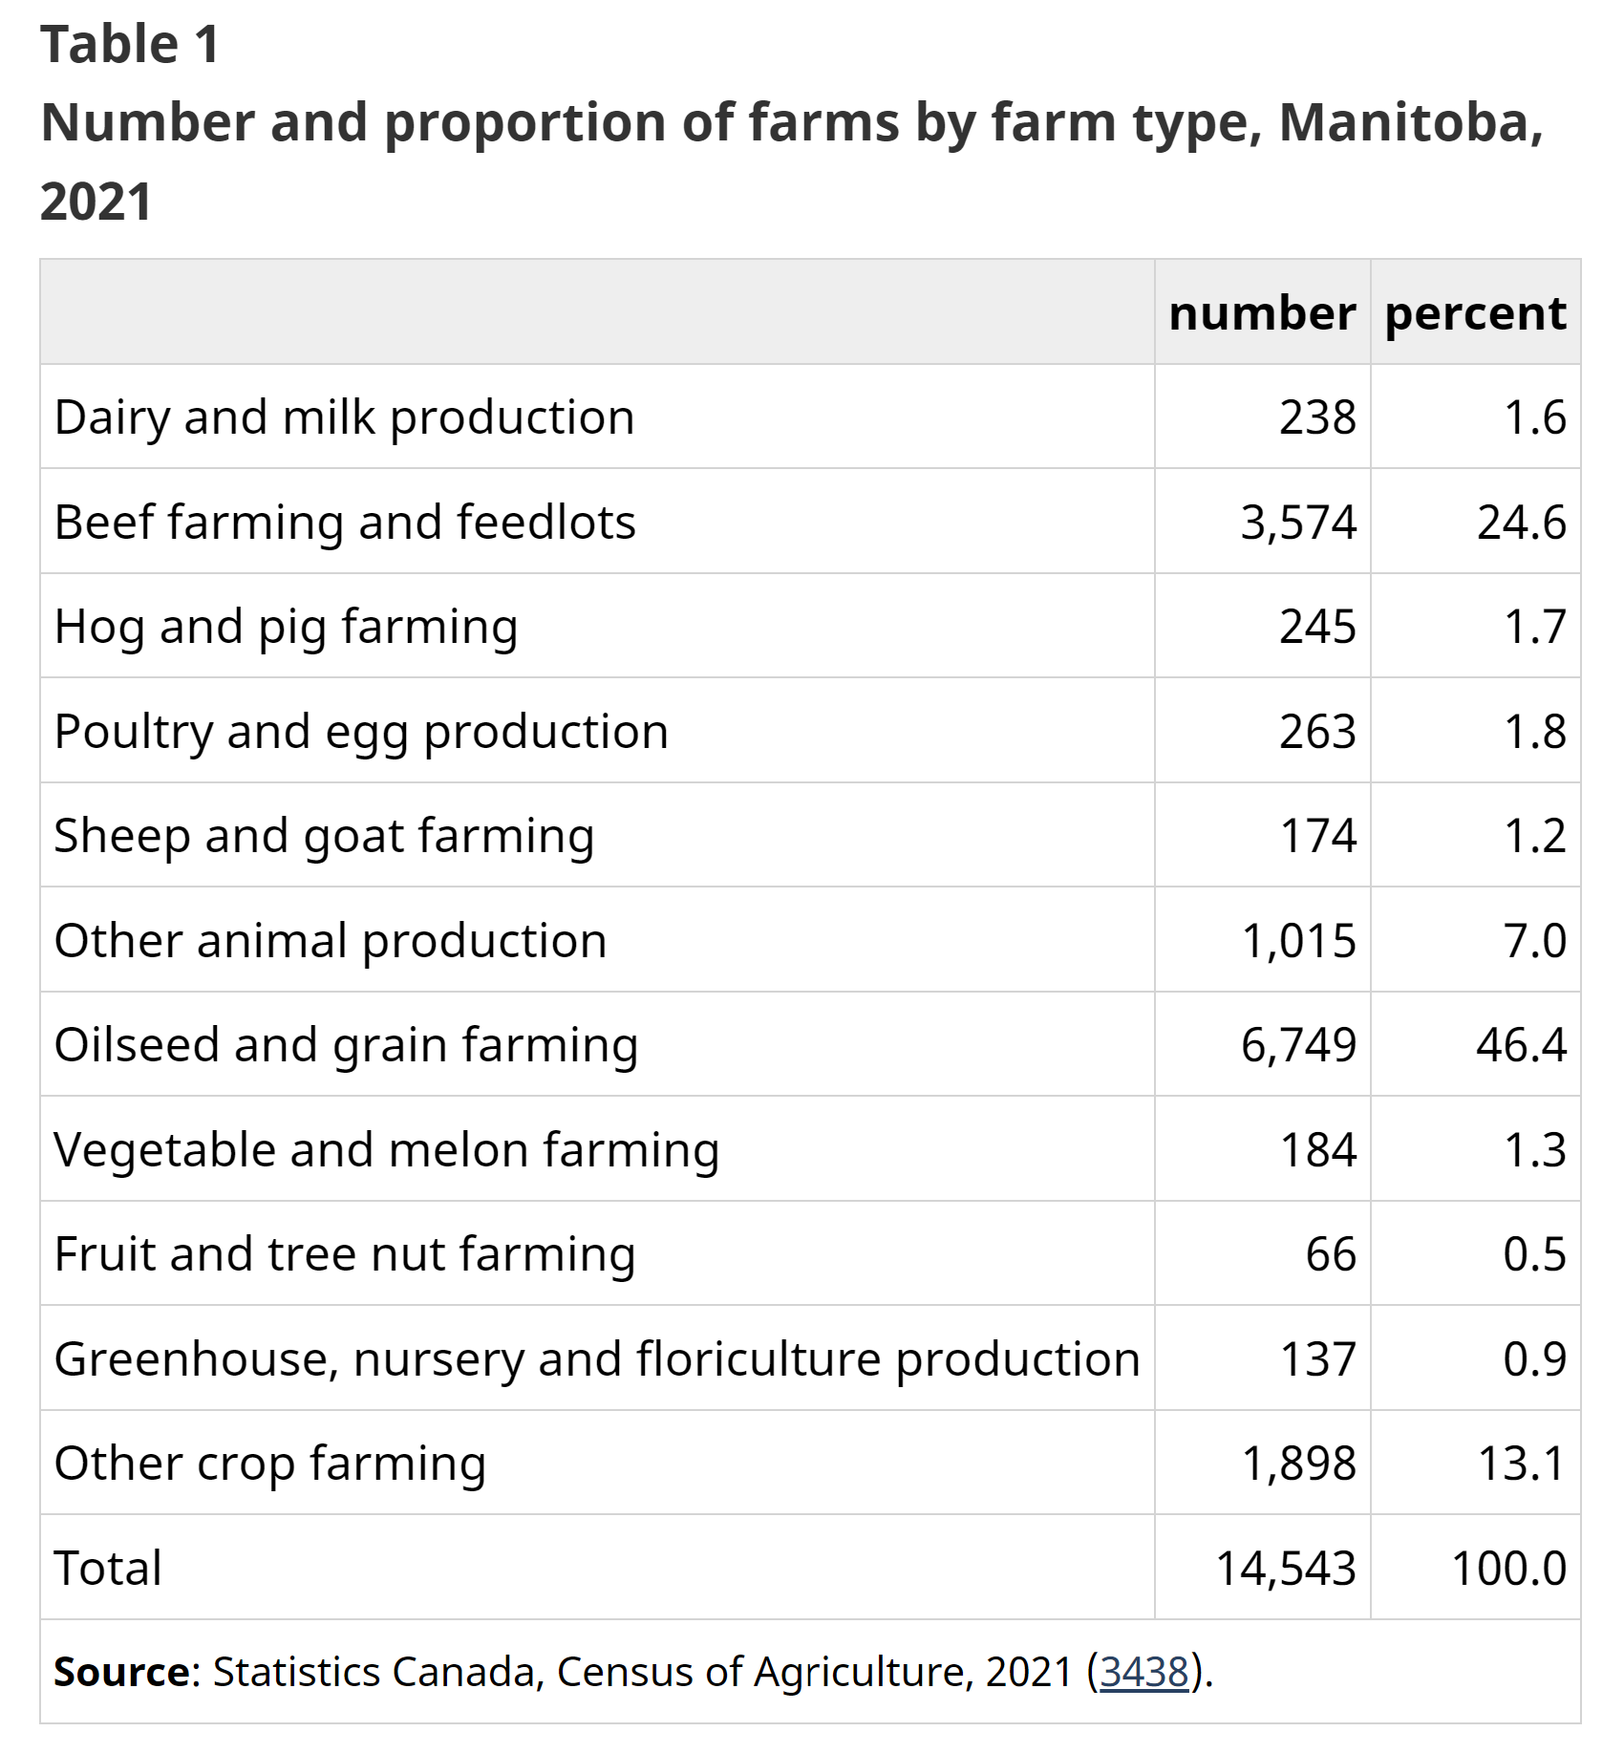

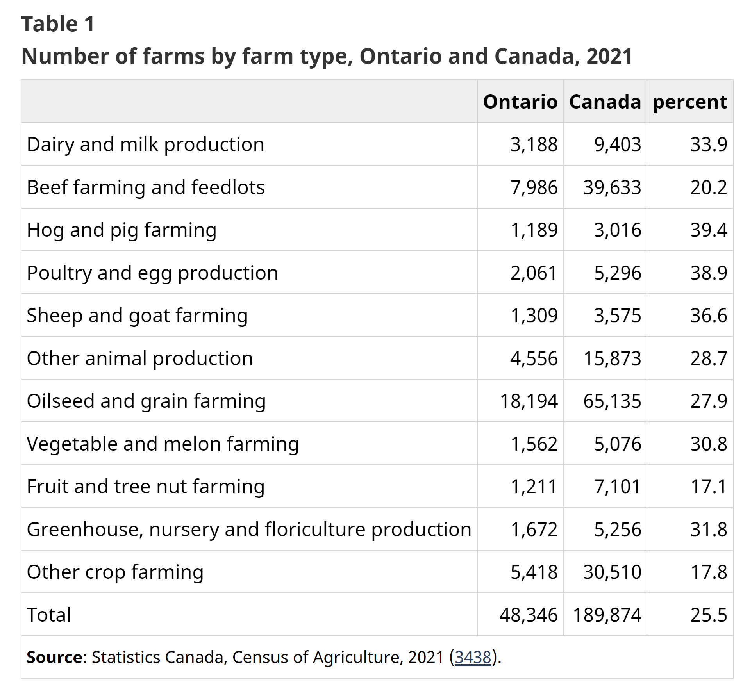

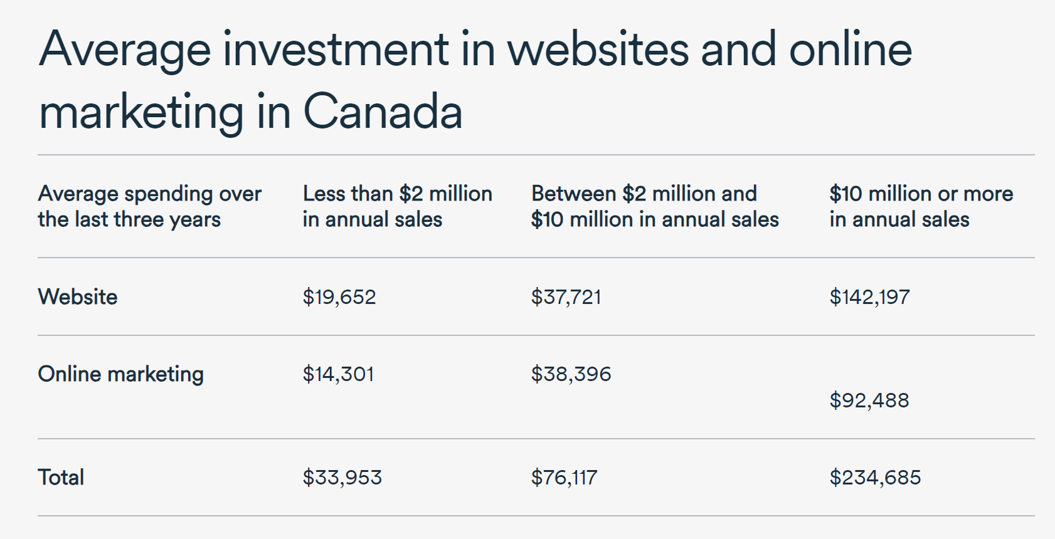

###### **Appendix L: Employee Timeline**

*Employee details for hiring timeline ( salary, number of employees, employee roles, training and travel costs, skills and responsibilities)*

**Abhay Gupta**

Training

EngSci

Expertise

Abhay has managed large scale logistics for a business in India. His experience will also be important for planning further expansion after our R&D Phase.

**Ritvik Singh**

Training

EngSci with Major in AI

Expertise

Ritvik has accredited experience in designing precise AI/ML models working with real-time data owing to his experience in the agro start up and military project space.

Connections

Ritvik’s ventures in the agro start up space and contacts with the agricultural unions of Bihar and Tamil Nadu, and heads of agricultural universities of Bihar and Kashmir provides the team with crucial soil nutrient data needed to train the AI model.

**Shalin Bakshi**

Training

Mechanical Engineer with Minor in Business

Expertise

Shalin has accredited experience in manufacturing design and heat management systems. His expertise facilitates cost effective manufacturing for the SoilMate box in order to make it durable and impermeable to the farmland environment.

**Shaurya Benipuri**

Training

Computer Engineer

Expertise

Shaurya has experience in producing and deploying production ready business applications complete with frontend and backend infrastructures and IoT integrations in compliance with user accessibility and data privacy guidelines. His expertise will facilitate the creation and management of the SoilMate app.

**Vidhan Purohit**

Training

Electrical Engineer with Minor in Control Systems

Expertise

Vidhan has accredited experience in real time signal processing circuits and soil nutrient chemistry owing to his NGO focusing on forest environments.

His expertise facilitates the integration of the various sensors needed to acquire soil parameters.

**Hiring Timeline**

Quarter 1:

The team would need to hire:

* 3 ML engineers at $30000/per year for AI model R&D and data acquisition
* 1 Agro-chemist specializing in environmental chemistry at $5000/year for research into soil chemistry, electrical sensor calibration and LED spectrometer calibration. Their expertise would also be beneficial in evaluating the soil chemical nutrient data acquisition processes we perform
* 1 Electrical Optics engineer at $6000/year for the development and calibration of the LED spectrometer, they will also be responsible for testing the integrated product’s electrical properties

These employees will be hired from India and their salaries are based on the current Indian rates. Assuming a 2 week training time we have a training cost of an additional $1708.3 based on wages paid during the training period.

Quarter 2:

The team would need to hire:

* 1 Full Stack Developer at $8000/year to produce frontend, backend and server pipeline architecture to actuate our IoT devices and transfer data to and from the device
* 2 Software Installation Engineers at $16000/year to code the in-device software functionalities to actuate the IoT capabilities and to ensure software, update and data delivery to our devices remotely during the trial phase
* 1 Mechanical Design Engineer at $6000/year to design the heat management and waterproofing simulations

These employees will be hired from India and their salaries are based on the current Indian rates. Assuming a 2 week training time we have a training cost of an additional $1250 based on wages paid during the training period.

Quarter 3:

The team would need to hire:

* 1 Customer Service representative at $4000/year to respond to and report customer needs and bug fixes of the product where end users from Canada, India, Australia, Africa and the GCC use the SoilMate offering to test their soil nutrient content.

This employee will be hired from India and their salaries are based on the current Indian rates. Assuming a 2 week training time we have a training cost of an additional $166.6 based on wages paid during the training period.

Quarter 4:

The team would need to hire:

* 1 Canadian Sales rep experienced in selling hardware electronics at $50000/year for performing farm to farm sales. They also have an additional travel and food cost of $5000/year associated.
* 1 Warehouse Manager in India at $6000/year to record, report and ensure the logistics pipelines for the manufacturing, storage and delivery of our product to our end users.

Assuming a 2 week training time we have a training cost of an additional $2330 based on wages paid during the training period.

Quarter 5:

No Additional Hiring

Quarter 6:

No Additional Hiring

Quarter 7:

* 1 Agro-chemist specializing in environmental chemistry at $5000/year for calibration of the physical sensors to the field data collected from the consumer trial period
* 1 Electrical Optics engineer at $6000/year for calibration updates of the LED spectrometer used by our users, they will also be making necessary design changes better suited to process in the field environment
* 1 Full Stack Developer at $8000/year to monitor the app frontend, backend, server pipeline architecture, IoT devices and transfer data to and from the device

This employee will be hired from India and their salaries are based on the current Indian rates. Assuming a 2 week training time we have a training cost of an additional $791.6 based on wages paid during the training period.

Quarter 8:

No Additional Hiring

The team will not hire any new employees in Quarter 5 to 8 as the team has 5 co-founders with the appropriate skills needed to manage the design, manufacturing, monitoring and delivery of the product to the end user. Each member of the team believes in operating a small but dynamic team of skilled individuals for each aspect of the company.

###### **Appendix M: Key partners**

**Research and Development:**

1. FIELDS Institute of Mathematics

**Dr. Kumar Murthy**, Director of the Fields Institute of Mathematics provides mentorship in fields of research, market development, marketing, business strategy and product development. Through his experience, industry connections and insights, he is able to provide us with valuable advice from time to time on various matters.

1. Kimia Analytics

Kimia Analytics is a startup associated with the University of Toronto operating in the Inductive Coupled Plasma (ICP) Rapid Elemental Analysis field developing precision spectrometers. They have offered their much required services for our research and development which would be essential in developing our prototype and final product.

1. Department of Agriculture Kashmir

**Dr Inam Bhatt** (Our representative of IIKSTC and SKUAST- Srinagar) provides mentorship on topics related to soil chemistry, customer education, agritech industry dynamics, and resources such as soil data, research, product testing facilities, and a network of potential farmers/customers.

1. Agricultural University of Bihar (PUSA)

**Dr. Ashok Kumar Singh**, Director of Agricultural University of Bihar is a data, research and development partner that can assist us in gaining product and market validation in Bihar, India.

1. Professor Micheal Guerzhoy

**Prof. Micheal Guerzhoy**, assistant professor, Faculty of Applied Science and Engineering, Division of Engineering Science is our mentor helping us develop, train, test, validate and iterate the product’s software and AI/ML model.

1. Dr. Chirag Variawa

Dr. Chirag Variawa, Director of First Year Curriculum, continuously helps us gain valuable resources, connections, mentors and partners essential to our operation.

1. Department of Agriculture & Farmers Welfare Kashmir (DA & FW)

Mr. Chowdhary Mohammad Iqbal, Director of Department of Agriculture & Farmers Welfare Kashmir, provides us with his insights into the agricultural and agri-tech space, helping us gain product and market validation in Kashmir and possibly other states of India.

**Logistics and Manufacturing:**

1. Creative Hitech

Creative Hitech is a leading EMS (electronics manufacturing service) company based out of Delhi, India. They are our product manufacturing, prototyping, testing and development partners. They will assemble and source raw materials from suppliers necessary for our product. Moreover, they will be producing our product completely in-house driving costs down and minimizing manufacturing related complications. Additionally, lending us industry information, insights and supply chain solutions.

1. Bluesky/VRL Logistics

Bluesky is our logistics and delivery partner within India. Through existing and established relations of the team with this company, Bluesky can provide their services to us at subsidized costs to help reduce our expenses on logistics.

1. Mac-nels

Mac-nels is our freight and logistics partner responsible for transporting our products from India to Toronto and vice-versa. Through long-term prior business relations of our founders, their services will be provided at subsidized rates that will increase profit margins.

1. ABC International/ NCI

ABC International will provide us with staff, warehouse management and packaging solutions in India. Being a family business of one of the co-founders, they will provide services at minimum prices ensuring quality, trust and reliability.

**Suppliers and Server Management:**

1. ThorLabs

ThorLabs, an optical equipment company based out of Newton, New Jersey, will be essential for our product, providing us high-precision visible light LED’s.

1. LMS

LMS, will be our supplier for their patented Near-Infrared (NIR) LED’s which are essential for generating spectroscopic scans.

1. Arduino

Arduino IC Device

1. AWS Cloud Services

We will be availing the services of AWS Cloud Services for data and server management, cloud services and business solutions.

1. Bluehost

Bluehost is an established organization ensuring reliability and quality in hosting and management of mobile apps and websites. We will be partnering up with them to host our website.

1. Google Collab

Services provided by Google Collab, namely, computing and server units, will be utilized in the research and testing phase of our product.

1. GoDaddy

GoDaddy will be used to purchase and maintain our domain name which will ensure smooth and reliable functioning.

1. CanadaPost

CanadaPost will be our delivery partners within Canada. CanadaPost additionally provides multiple opportunities for small businesses to minimize their delivery costs through programs and subsidized rates.

1. Purolator

We will avail services of Purolator for freight within North American markets. Initially, they will transport our container consignments from the ports to our warehouse.

1. Unloading Solutions

A company based out of Brampton, Ontario which will provide their services in unloading/destuffing and inventory management of our container consignments at the port.

**Sales and Market Partners:**

1. Unicorn International LLC

We plan to use Unicorn LLC’s resources and capabilities to penetrate the Omani agricultural market. Given their established presence and relationships with Omani greenhouses, they serve to be an important partner in the region.

1. Agricultural Union of Bihar
2. Agricultural Union of Tamil Nadu

***Appendix L: Assumptions during cost estimation. Elaborated in Cash flow***

The following assumptions have been made during this cost estimation:

* Estimated selling price of the final product is $3435 in Canada for individual sales, and $2750 for international bulk sales.
* The prototyping and testing phase is assumed to last for 8 months.
* We assume that certain roles, such as Machine Learning Engineers, Mechanical Design Engineer, Agro-chemist , Electrical Optics Engineer, Full Stack Developer, Warehouse Manager, and Customer Service Representative, are outsourced to India to reduce costs. The salaries for these roles are based on the average market rates in India.
* We assume that one sales representative is needed in Canada, and the salary cost reflects Canadian market rates.
* The costs of the components used in the prototype and final product are assumed to be relatively stable, and the prices are gathered from the current market rates as of the time of the cost projection.
* We've assumed that ABS plastic will be used for the product and that the cost of assembly is consistent per unit.
* We assume that the product will be manufactured in India and then shipped to Canada. All relevant costs such as warehousing, insurance, freight, and delivery are considered based on current market rates.
* Based on the nature of the industry, we assume a relatively high Customer Acquisition Cost (CAC).
* After July 2024 (full scale production), we aim to sell 3064 units in 24 months.

***Appendix M: Specifics regarding instruments and logistics/manufacturing***

Our operations for producing the highest quality product necessitate specific instruments like a spectroscope and a chemical lab setup, both of which are vital tools for ensuring the accuracy and reliability of our soil analysis. We also require access to state-of-the-art labs and specialized lab equipment for testing and benchmarking. Our R&D processes are fueled by continued collaborations with various partners who enrich our knowledge pool and keep us abreast of the latest developments in relevant fields, helping us maintain our cutting-edge.

In the realm of logistics and manufacturing, our collaborative partnerships span several key entities: Creative Hitech, a firm specializing in Electronics Manufacturing, and Unloading Solutions, which takes care of Inventory Management. In terms of freight, we work with an array of organizations, such as Canada Post and Purolator for North American freight, Bluesky/VRL for domestic logistics, and Mac-Nels and ABC International/NCI for International Freight.

###### **Appendix N: Gantt Chart for detailed timeline and a verbose overview of the timeline**

| We are in the process of acquiring customers in Canada and abroad in markets like India and the GCC. Partnering with various agricultural organizations, agritech solutions distributors, consultants and experts in the field to gain better insights into the product. |
| --- |



| Starting September 2023, we will start our hiring round and develop our MVP (minimum viable product). Through our identified suppliers, we will obtain the necessary components for our MVP after securing a pre-seed fund of $110,000 with a further $91,500 dollars secured in November 2023 and January 2023 |
| --- |



| In February 2024, this MVP will be rolled out for on-site testing and delivered to interested customers for data acquisition while we conclude our first funding round of $150,000 |
| --- |



| In February 2024, the team deploys its funds deployment plan after concluding the seed funding round, setting targets for the fiscal year after the customer feedback and usage data have been used to make calibrations to our MVP. |
| --- |



| Through the data collected, our R&D team will converge on the final design aspects of the product based on customer feedback and market response by April 2024. |
| --- |



| The team intends to meet its certification requirements per sales region by May 2024, in order to facilitate its product deployment plans to supply 3084 units into Canada, India and GCC in June 2024 and proceed with overall manufacturing in July 2024 while securing a second funding round of $250,000 |
| --- |



| With delivery of products in Ontario and Alberta projected to start after July 1 2024 with an additional funding round of $250,000 on October 24, the team continually improves the product for a newer version as manufacturing and sales continue. |
| --- |

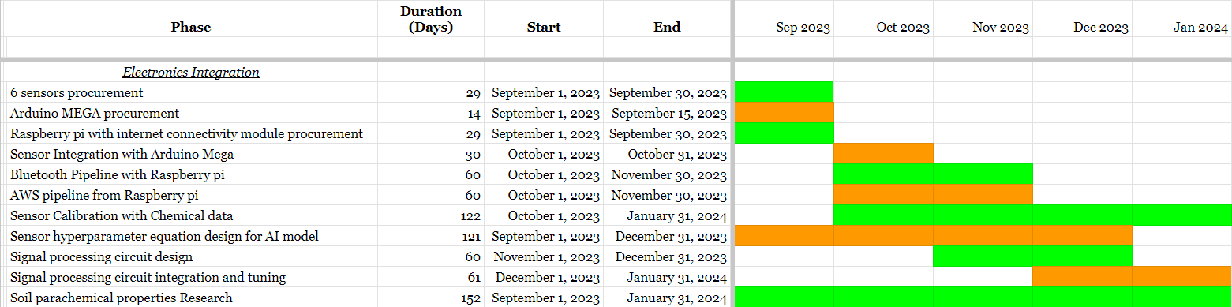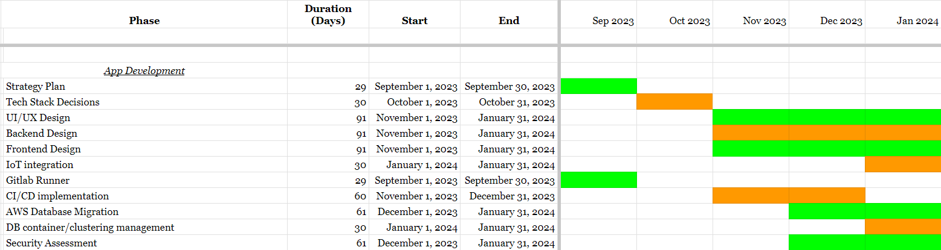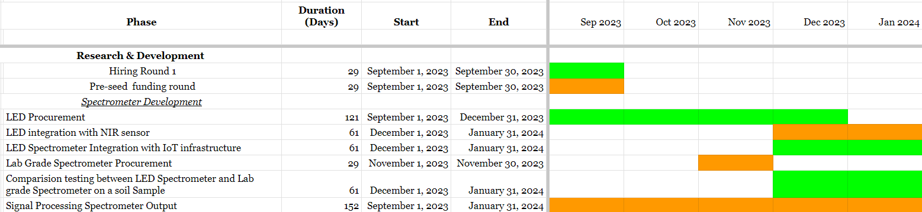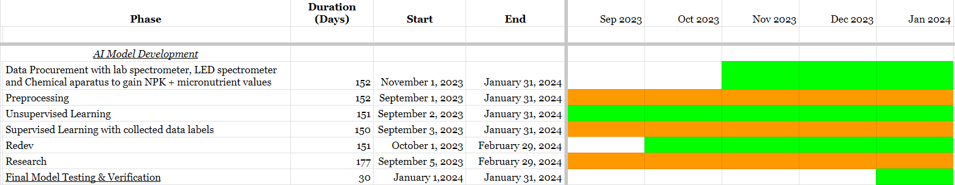

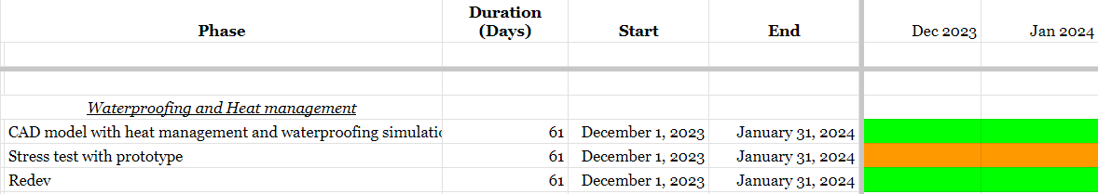

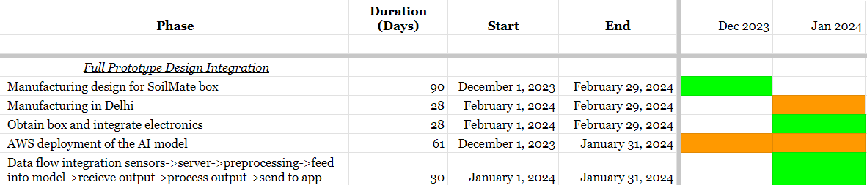

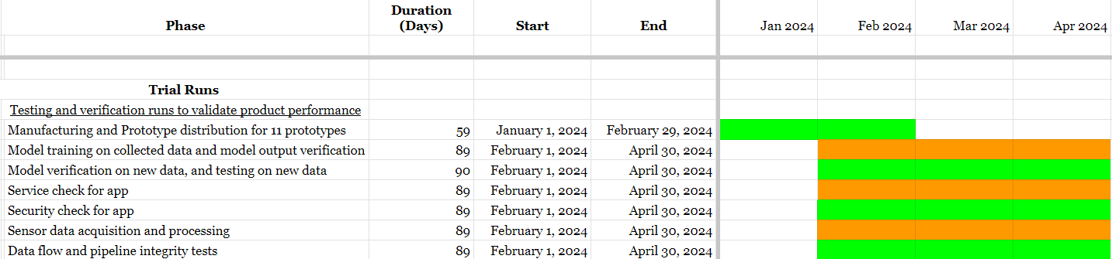

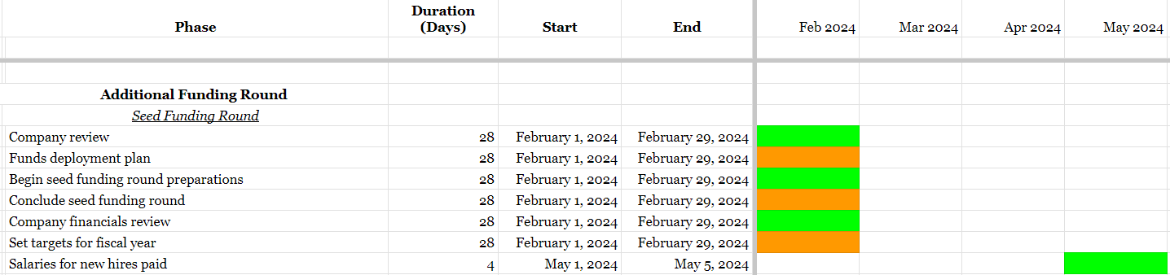

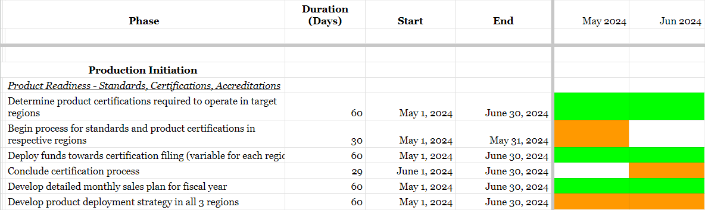

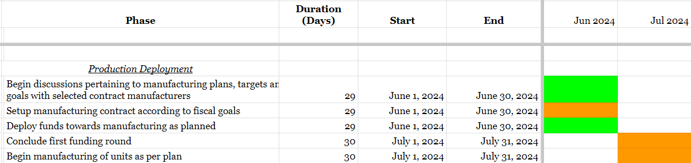

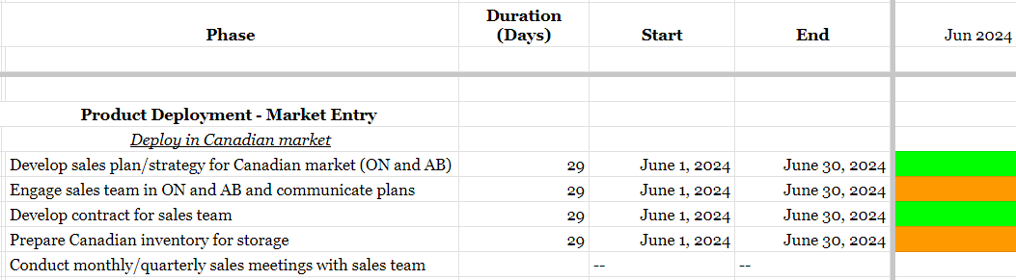

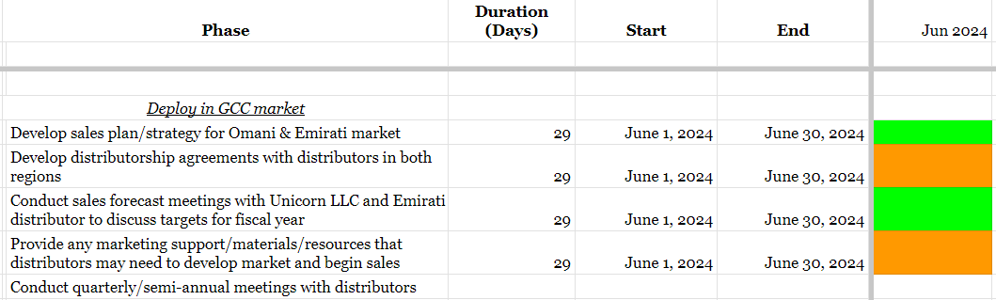

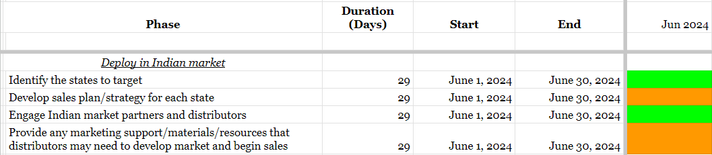

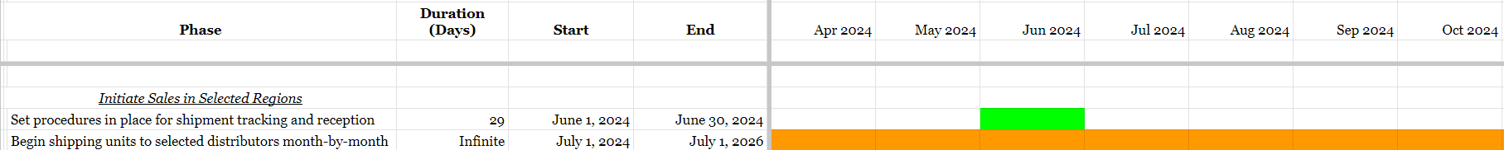

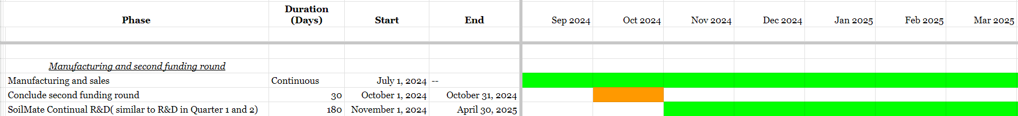

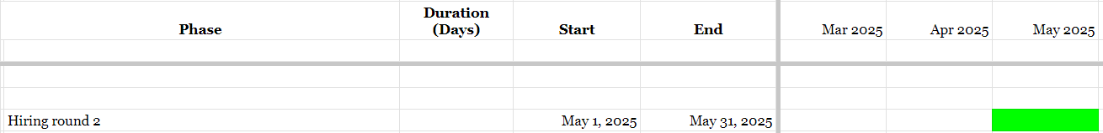

#### **Bibliography**

1. K-State Research and extension. Lawn & Garden Soil Test. Accessed July 25, 2023. <https://www.douglas.k-state.edu/lawn-garden/lawn_garden_soiltest.html>.

2. Warncke DD. Sampling soils for fertilizer and lime recommendations and frequency of soil sampling (E0498). MSU Extension. Accessed July 24, 2023. <https://www.canr.msu.edu/resources/farm_soil_sampling>.

3. Massow M von. Average farm size has stopped growing. Food Focus Guelph. September 8, 2022. Accessed July 24, 2023. <https://www.foodfocusguelph.ca/post/average-farm-size-has-stopped-growing#:~:text=Average%20farm%20size%20in%20Canada,the%20previous%20census%20in%202016.&text=The%20decline%20is%20the%20first,as%20illustrated%20in%20Figure%201>

4. Krasilnikov P, Taboada MA, Amanullah. Fertilizer use, Soil Health and Agricultural Sustainability. MDPI. March 25, 2022. Accessed July 24, 2023. <https://www.mdpi.com/2077-0472/12/4/462>.

5. Humic P by BE. Should you care about water retention? Black Earth. March 21, 2020. Accessed July 24, 2023. <https://blackearth.com/should-you-care-about-water-retention/>.

6. Ball J. Soil and water relationships. Noble Research Institute. June 21, 2023. Accessed July 24, 2023. <https://www.noble.org/regenerative-agriculture/soil/soil-and-water-relationships/>.

7. Jauron R. The meaning and importance of soil ph. Horticulture and Home Pest News. Accessed July 24, 2023. <https://hortnews.extension.iastate.edu/2002/5-24-2002/soilph.html>.

8. Gong L. Soil electrical conductivity(ec): What’s it, why important, how to measure & more. Latest Open Tech From Seeed. February 28, 2023. Accessed July 24, 2023. <https://www.seeedstudio.com/blog/2022/07/15/soil-electrical-conductivity/>.

9. Government of Canada SC. Canada’s 2021 Census of Agriculture: A story about the transformation of the agriculture industry and adaptiveness of Canadian farmers. The Daily - . January 9, 2023. Accessed July 24, 2023. <https://www150.statcan.gc.ca/n1/daily-quotidien/220511/dq220511a-eng.htm>.

10. Field vegetable production in Canada. Fruit & Vegetable Growers of Canada. Accessed July 24, 2023. <https://fvgc.ca/about-us/horticulture-stats/field-vegetable-production-in-canada/#:~:text=Number%20of%20farms%20in%20Canada%3A%209%2C057>.

11. Categorisation of Farmers. February 5, 2019. Accessed July 23, 2023. https://pib.gov.in/Pressreleaseshare.aspx?PRID=1562687.

12. Narayanan A. Greenhouses to vertical farming: The Middle East’s path to Foolproof Food Security. Al Arabiya English. December 1, 2022. Accessed July 25, 2023. <https://english.alarabiya.net/News/gulf/2022/11/30/Greenhouses-to-vertical-farming-The-Middle-East-s-path-to-foolproof-food-security>.

13. Achard S. Saudi Arabia unveils USD 1BN Investment Plan in greenhouses. iGrow News. January 5, 2023. Accessed July 25, 2023. <https://igrownews.com/saudi-arabia-unveils-usd-1bn-investment-plan-in-greenhouses/#:~:text=The%20percentage%20of%20investment%20profits,73%2C542%20greenhouses%20in%20Saudi%20Arabia>.

14. Qarjouli A. Qatar’s greenhouse market to jump up to $309m by 2027. Doha News | Qatar. June 2, 2022. Accessed July 25, 2023. <https://dohanews.co/qatars-greenhouse-market-to-jump-up-to-309m-by-2027/>.

15. Bihar. Accessed July 24, 2023. <https://farmech.dac.gov.in/FarmerGuide/BI/index1.html#:~:text=The%20total%20number%20of%20land,hold%20land%20above%202%20hectare>.

16. Mondal S. (PDF) impact of climate change on soil fertility - researchgate. Accessed July 24, 2023. <https://www.researchgate.net/publication/355200115_Impact_of_Climate_Change_on_Soil_Fertility>.

17. Van Dijk M, Morley T, Rau ML, Saghai Y. A meta-analysis of projected global food demand and population at risk of hunger for the period 2010–2050. Nature News. July 21, 2021. Accessed July 24, 2023. <https://www.nature.com/articles/s43016-021-00322-9>.

18. Badreldin N, Lobb DA. The Costs of Soil Erosion to Crop Production in Canada between 1971 and 2015. Sustainability. 2023;15(5):4489. doi:<https://doi.org/10.3390/su15054489>

19. Badreldin N, Lobb DA. The costs of soil erosion to crop production in Canada between 1971 and 2015. MDPI. March 2, 2023. Accessed July 24, 2023. <https://www.mdpi.com/2071-1050/15/5/4489>.

20. Chapter 2 crop losses and their causes - Canadian phytopathological society. Accessed July 24, 2023. <https://phytopath.ca/wp-content/uploads/2015/03/DPVCC-Chapter-2-Crop-losses.pdf>.

21. Federal government’s plan to cut fertilizer emissions by 30% by 2030 must remain voluntary for Canadian agri-businesses. Canadian Federation of Independent Business. Accessed July 24, 2023. <https://www.cfib-fcei.ca/en/media/federal-governments-plan-to-cut-fertilizer-emissions>.

22. Thibaudeau B. New report warns of potential for $48 billion loss in farm income if fertilizer reductions are required of growers. Fertilizer Canada. June 28, 2023. Accessed July 24, 2023. <https://fertilizercanada.ca/news-events/news/new-report-warns-of-potential-for-48-billion-loss-in-farm-income-if-fertilizer-reductions-are-required-of-growers/>.

23. Soil sampling for better fertilization decisions. UNL Water. March 12, 2020. Accessed July 24, 2023. <https://water.unl.edu/article/animal-manure-management/soil-sampling-better-fertilization-decisions#:~:text=Soil%20sampling%20and%20testing%20are,cost%2C%20and%20minimize%20environmental%20impact>.

24. Macronutrients and micronutrients for the soil. Emerald Lawns. December 7, 2022. Accessed July 24, 2023. <https://emeraldlawns.com/macronutrients-micronutrients-soil/>

25. Operating lifetime study of ultraviolet (UV) light-emitting diode (led ... Accessed July 24, 2023. <https://www.energy.gov/eere/ssl/articles/operating-lifetime-study-uv-led-products>.

26. Determining the lifespan of a battery: Mastervolt . Mastervolt. Accessed July 24, 2023. <https://www.mastervolt.com/determining-the-lifespan-of-a-battery/>.

27. Ph sensor shelf life and expiration. pH Shelf Life and Expiration | pH Sensor FAQs | Hamilton Company. Accessed July 24, 2023. <https://www.hamiltoncompany.com/process-analytics/ph-and-orp-knowledge/ph-shelf-life-and-expiration-questions>.

28. Nitrate ion selective electrode RS485 output water quality sensor ca2+ ion electrode for waste water. Nitrate Ion Selective Electrode Rs485 Output Water Quality Sensor Ca2+ Ion Electrode For Waste Water - Buy Digital Nitrite Sensor,Online Ammonia Nitrogen Sensor,Digital Ammonia Nitrogen Sensor Product on Alibaba.com. Accessed July 24, 2023. <https://www.alibaba.com/product-detail/Nitrate-Ion-Selective-Electrode-RS485-Output_1600752505549.html>.

29. Arduino - Soil Moisture Sensor: Arduino tutorial. Arduino Getting Started. Accessed July 24, 2023. <https://arduinogetstarted.com/tutorials/arduino-soil-moisture-sensor>.

30.Admin. DIY soil ph meter using soil ph sensor & arduino. How To Electronics. August 21, 2022. Accessed July 24, 2023. <https://how2electronics.com/diy-soil-ph-meter-using-soil-ph-sensor-arduino/>.

31. Digital Signal Processor - DSP latest price, Manufacturers & Suppliers. IndiaMART. Accessed July 24, 2023. <https://dir.indiamart.com/impcat/digital-signal-processor.html>.

32. Fundamentals of soil cation exchange capacity (CEC). AY-238. Accessed July 24, 2023. <https://www.extension.purdue.edu/extmedia/ay/ay-238.html>.

33. Czarnecki S. Influence of long-term mineral fertilization on metal contents and ... Accessed July 24, 2023. <https://www.researchgate.net/publication/314815329_Influence_of_long-term_mineral_fertilization_on_metal_contents_and_properties_of_soil_samples_taken_from_different_locations_in_Hesse_Germany>.

34. 2 Crop Losses and Their Causes Figures 2.3a-q; 2.3T1 Tables 2.3a-d 2.1 Types of Crop Losses Production Losses Post-Harvest Losses 2.2 Causes of Crop Losses. <https://phytopath.ca/wp-content/uploads/2015/03/DPVCC-Chapter-2-Crop-losses.pdf>

1. For clarity, a **sample** refers to a single soil specimen, and **test** refers to the collective analysis of all the farm soil samples.
2. This number was determined by considering an average farm size of 800 acres[3] and a testing ratio of 1 sample per 2 acres, and testing 6 times a year - twice the recommended[2].
3. $600 worth of testing 3 times a year.
4. For the majority of our customers - we anticipate the first tier to be the most popular option because ideally, 2,500 samples is very large when compared to how many samples a farmer would typically need to test on average.
5. GCC includes Bahrain · Kuwait · Oman · Qatar · Saudi Arabia · United Arab Emirates.
6. These were the reasons identified by us from analyzing data and information collected via customer outreach in these provinces.
7. SAM is the market we aim to capture within 5 years of the inception of our production phase.
8. Calculation based on 20% success rate in Ontario.
9. Calculated based on 7% success rate in Alberta.
10. SOM is the market we aim to capture within 2 years of the inception of our manufacturing phase.
11. According to a 2020 Farm Journal Media survey in the United States, approximately 75% of farmers used social media, with over half predominantly active on Facebook.
12. The Canadian Agricultural Safety Association reported that 77% of farmers in Canada prefer to get their farming-related information from agricultural publications.
13. A 2020 study by the Canadian Centre for Food Integrity revealed that 80% of farmers are more likely to engage with businesses that have demonstrated reliability and commitment to the farming community
14. This was confirmed further via phone conversations with farmers.
15. By definition, these are crops grown to be sold internationally, and are often used as raw materials in manufacturing; unlike food-crops, which are primarily grown for domestic consumption.
16. This number was calculated by taking into account the difference in yields at recommended harvest periods v/s at harvest periods pushed by 2-3 weeks for various types of crops, specifically wheat and corn.
17. The number of harvest seasons can vary for different crops; for example, wheat can be grown and harvested twice in a year.
18. Includes: Organic Matter, Phosphorus, Potassium, Magnesium, Calcium, Sodium, Sulphur, Soil pH, Buffer pH, Cation Exchange Capacity, Percent Base Saturation of Cation Elements, Crop Removal.
19. Includes: Basic + ENR, K/Mg, Zinc, Manganese, Iron, Copper, Boron, Aluminum.
20. Includes: Standard + Total Organic Carbon (TOC), % Carbonate, Displacement CEC, Sand, Silt, Clay, Soil Type, Bulk Density, Water Parameters (Field Capacity, Wilting Point, Water Holding Capacity), DPS (Degree of Phosphorus Saturation)
21. Cumberland Valley Analytical Services has 2 additional market partners in Canada: one in British Columbia, and one in Quebec.
22. Ontario Ministry of Agriculture, Food and Rural Affairs
23. Includes: Organic Matter, Phosphorus, Potassium, Magnesium, Calcium, Sodium, Sulphur, Soil pH, Buffer pH, Cation Exchange Capacity, Percent Base Saturation of Cation Elements, Crop Removal.
24. Includes: Basic + ENR, K/Mg, Zinc, Manganese, Iron, Copper, Boron, Aluminum.
25. Includes: Standard + Total Organic Carbon (TOC), % Carbonate, Displacement CEC, Sand, Silt, Clay, Soil Type, Bulk Density, Water Parameters (Field Capacity, Wilting Point, Water Holding Capacity), DPS (Degree of Phosphorus Saturation)
26. Owing to their expansive acreage, large-scale farms require consistent, real-time soil testing data from across their territories. This enables them to discern and respond to the distinct nutrient levels and conditions in various farm sectors. Thus, the implementation of a greater number of soil testing probes becomes imperative, to provide the detailed, area-specific data necessary for the customization of agricultural strategies and optimized productivity.
27. According to a 2020 Farm Journal Media survey in the United States, approximately 75% of farmers used social media, with over half predominantly active on Facebook.
28. The Canadian Agricultural Safety Association reported that 77% of farmers in Canada prefer to get their farming-related information from agricultural publications.